

**Tecnológico de Monterrey Campus Chihuahua**

**Assembly guide of SPARC**

**Training Partner: Resideo**

**Involved teams:**

**Wisdom**

**Justice**

**Creativity**

**Temperance**

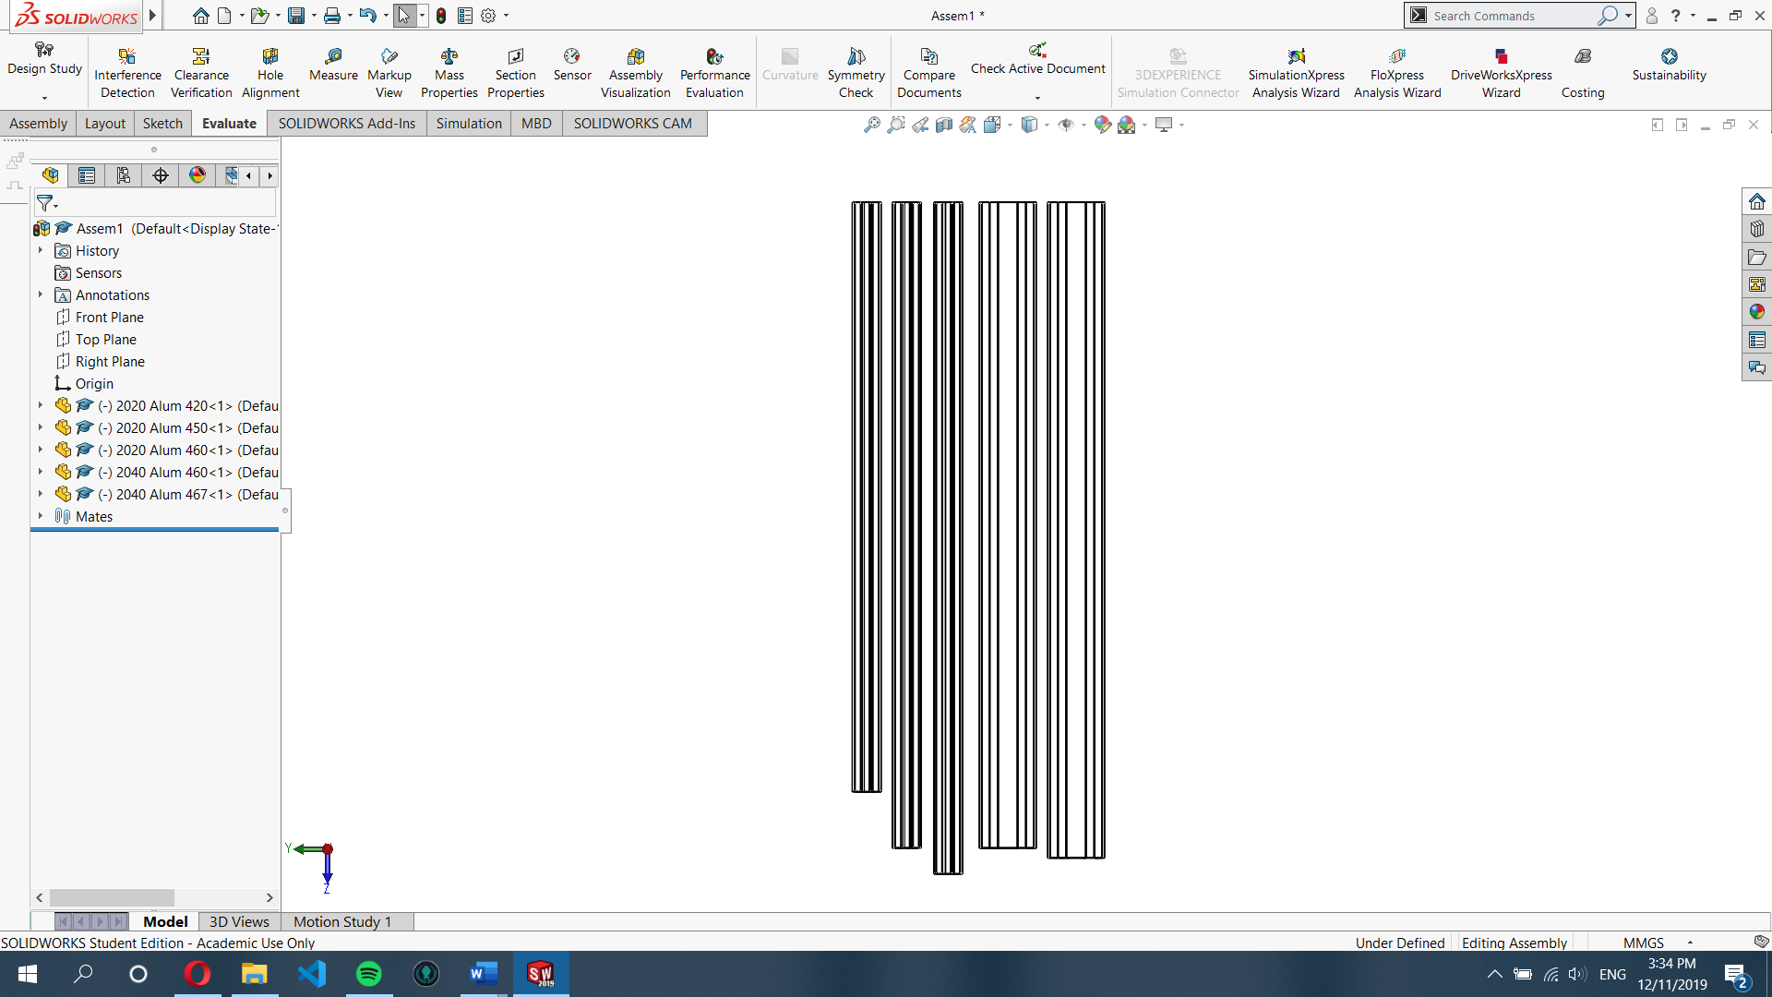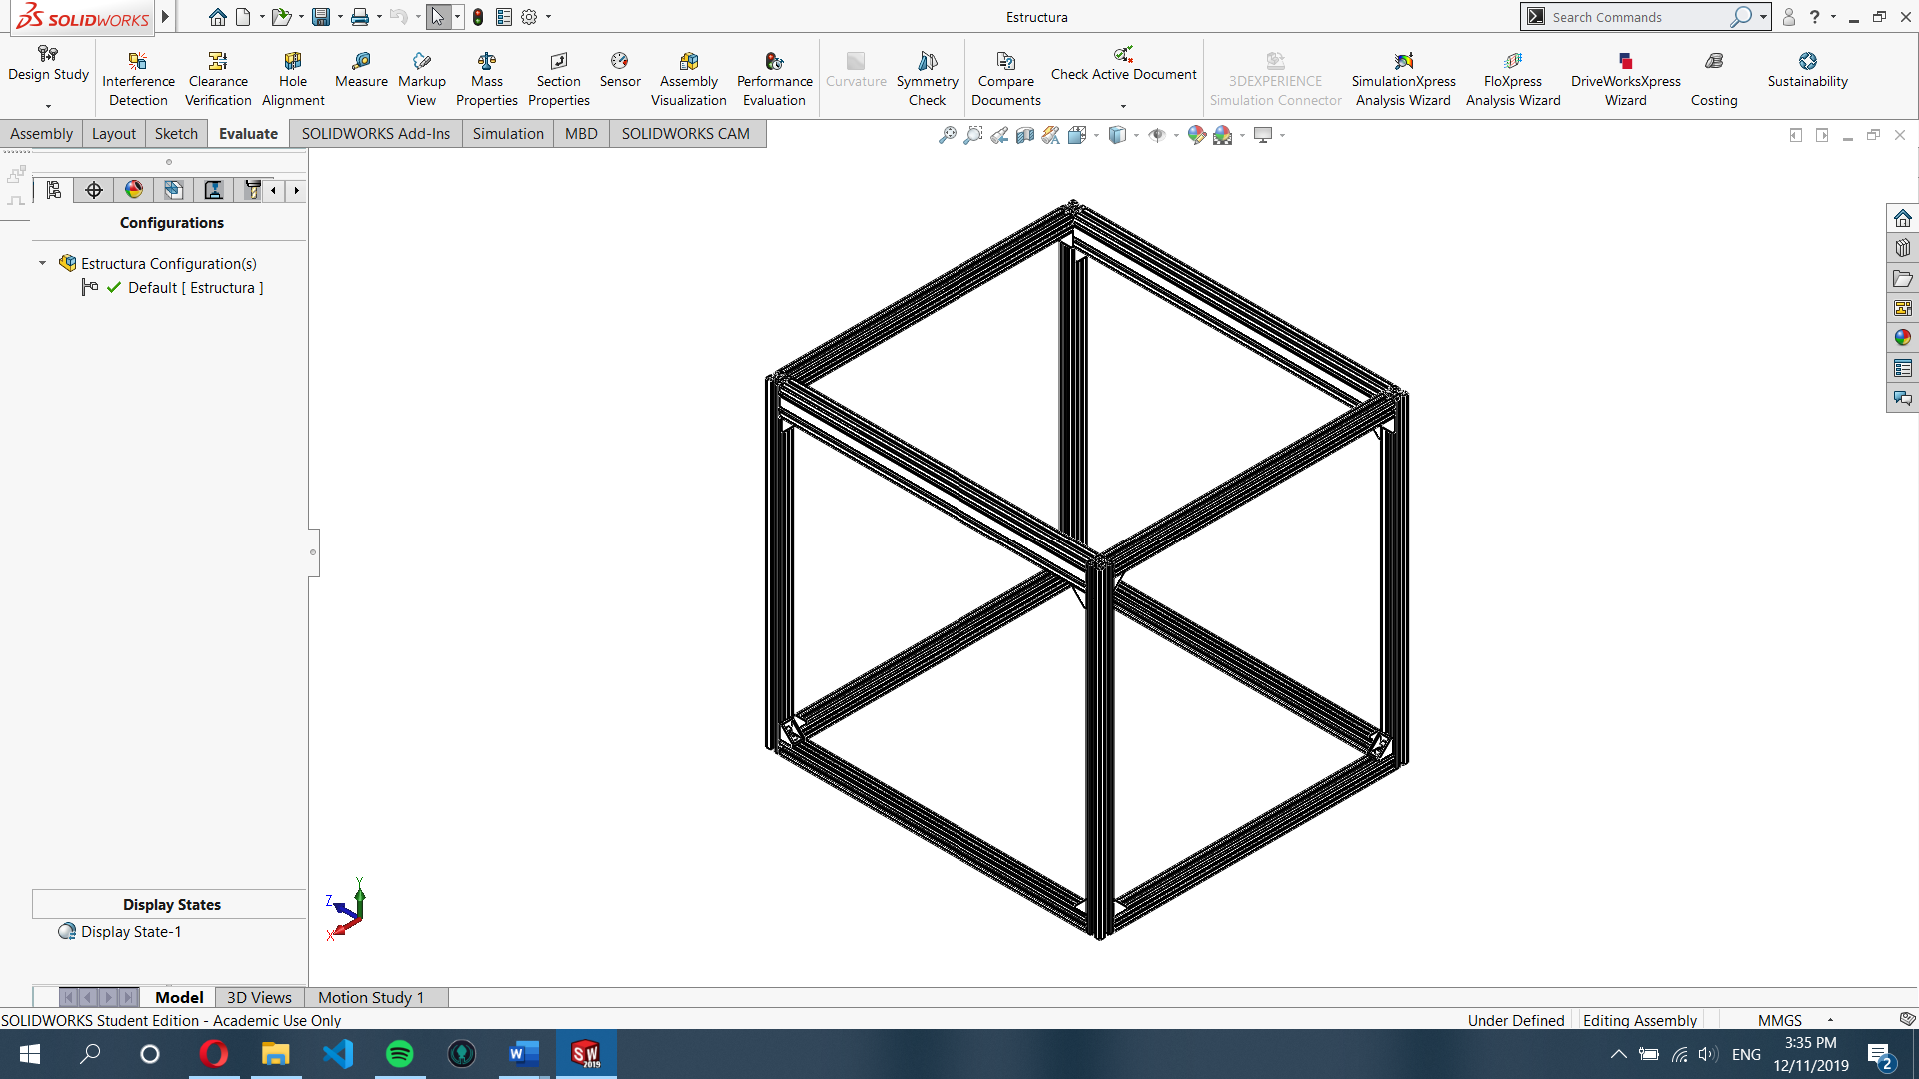

*This is an isometric view of the basic structure of SPARC, there are various alluminum profiles sizes:

* 4 of part A
* 2 of part B
* 4 of part C
* 2 of part D
* 1 of part E

NOTE: Go to page 14 to see CART assemble before assembling the frame, carts must be inside parts “D” and “E” before fixing the frame.

STEP 1: Place 1 corner bracket between part C and part B.

Note: All economy T-Nuts must be placed inside, repeat procedure for each profile.

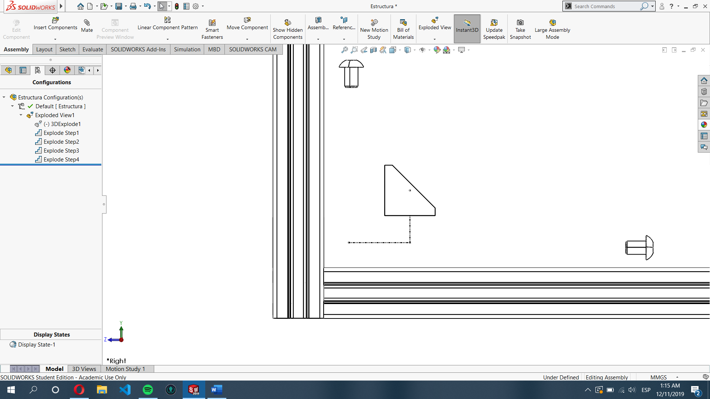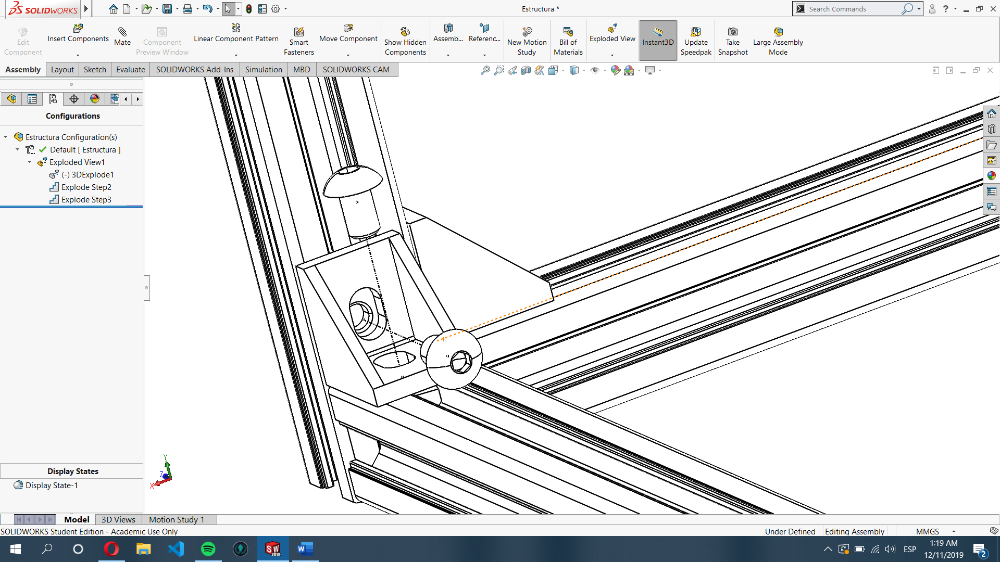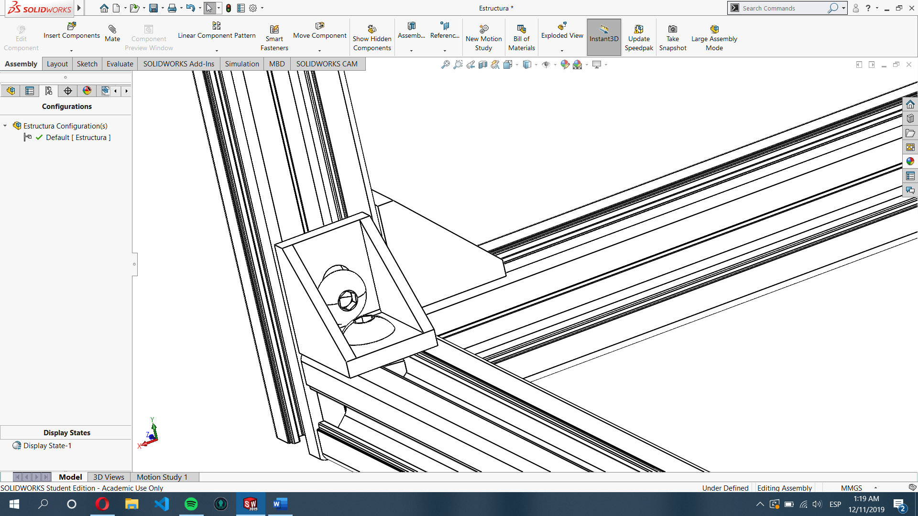M5x8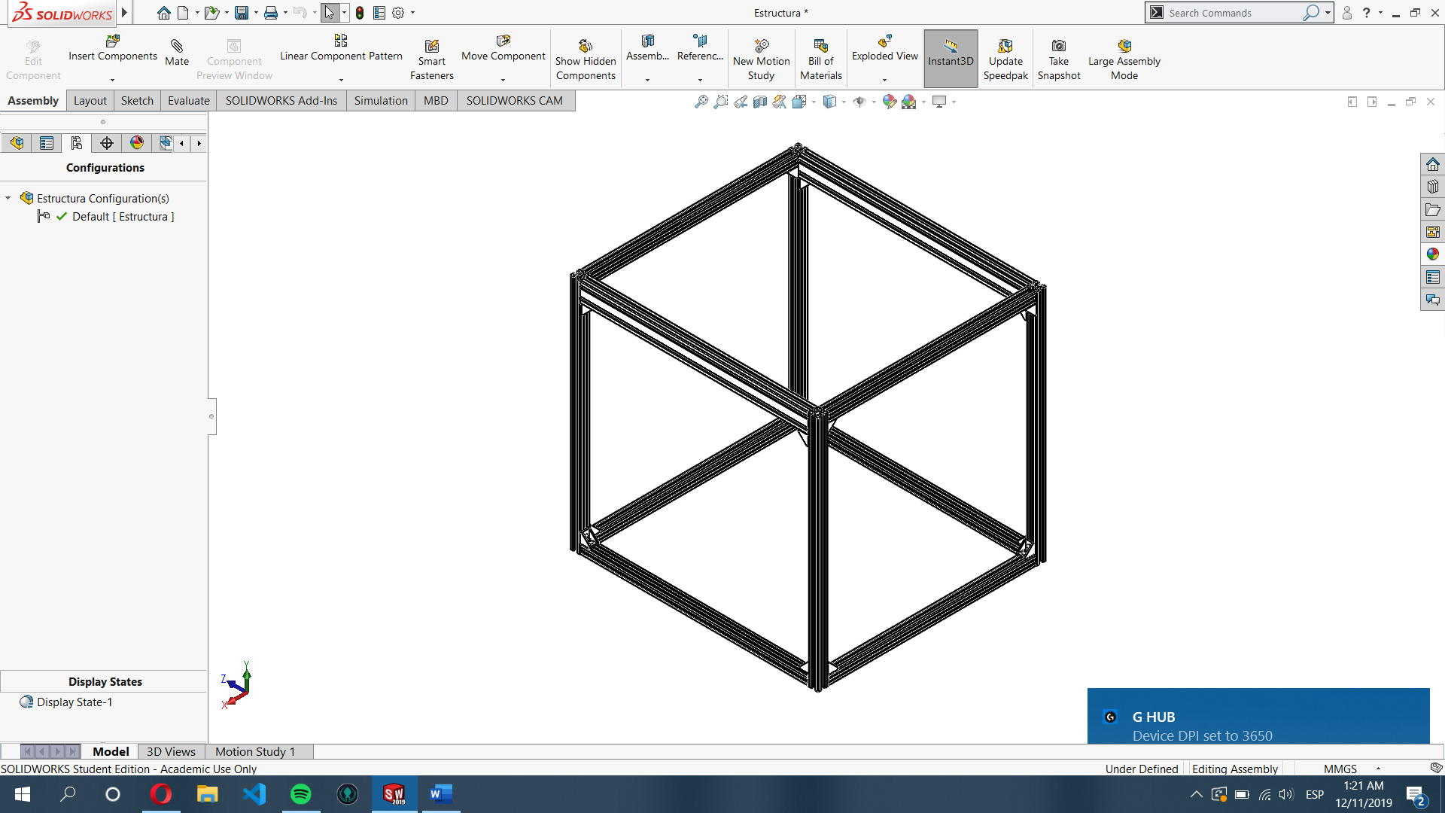

Inside look of T-Nut installation

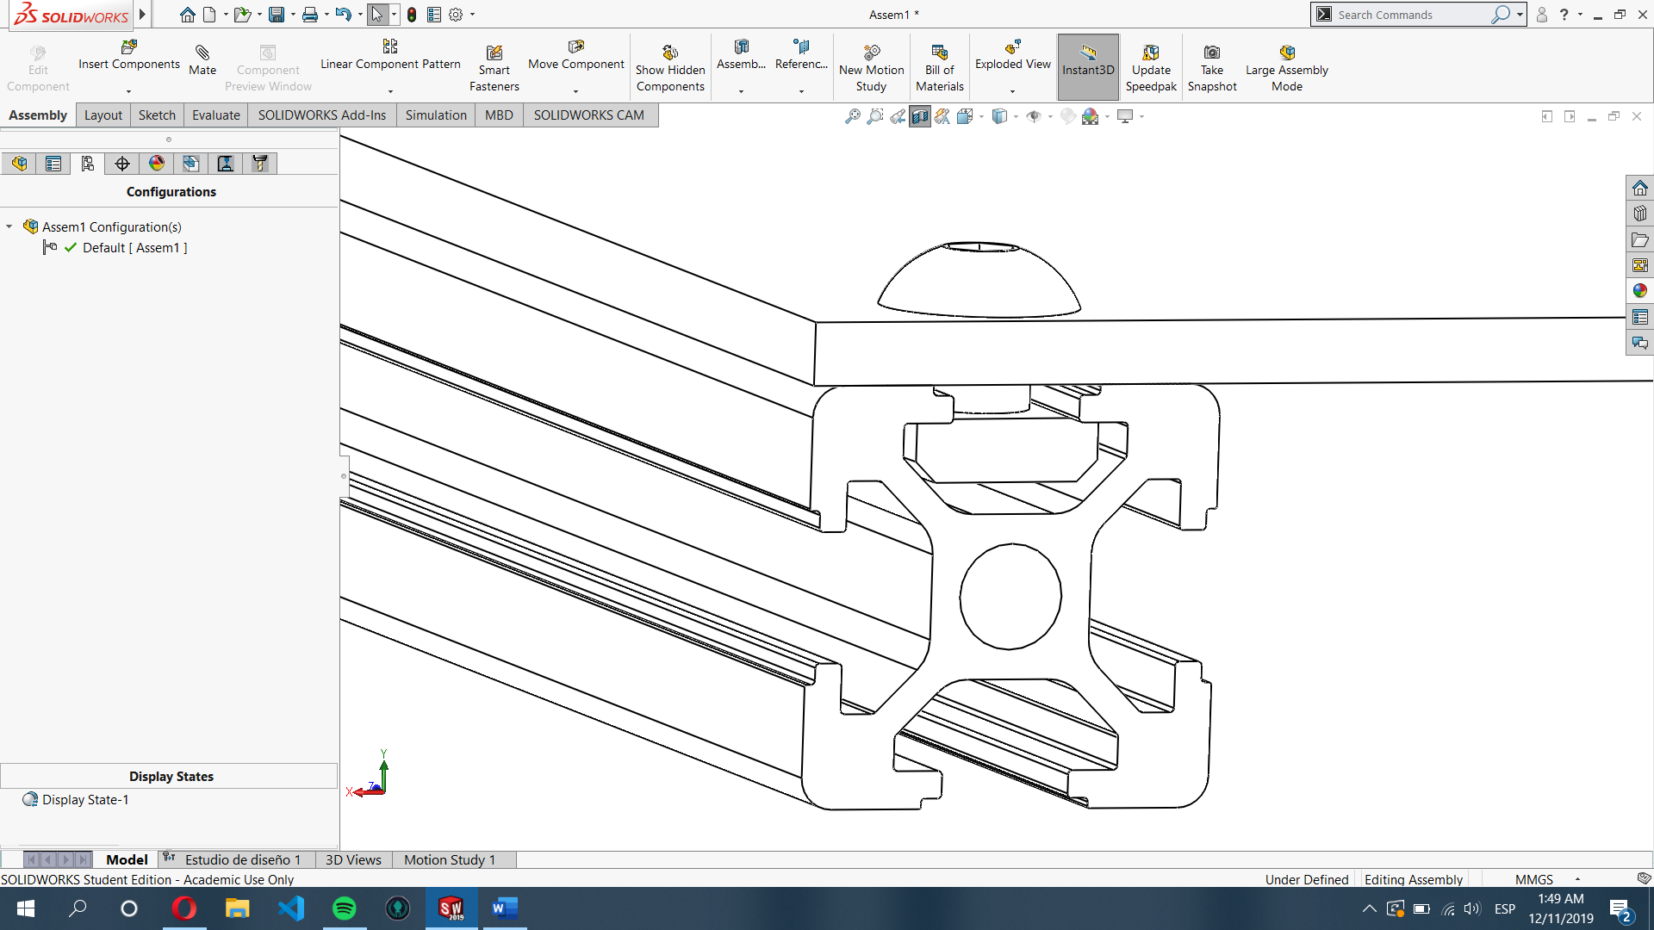

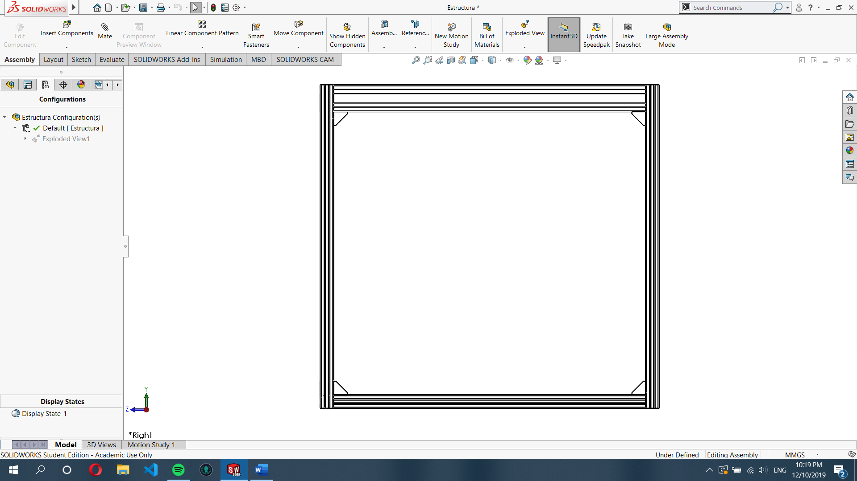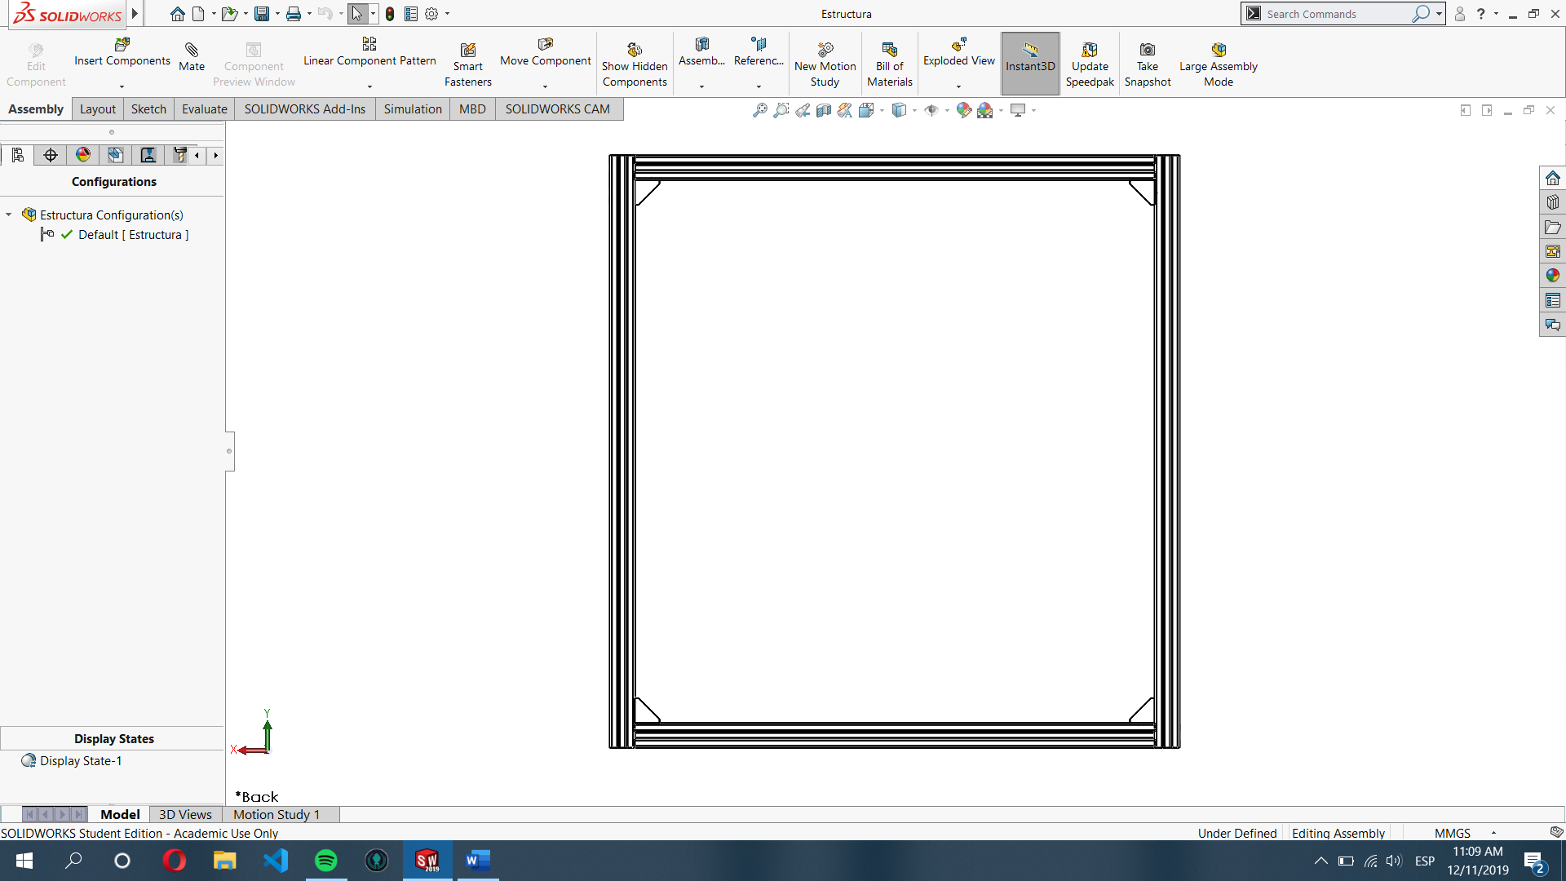

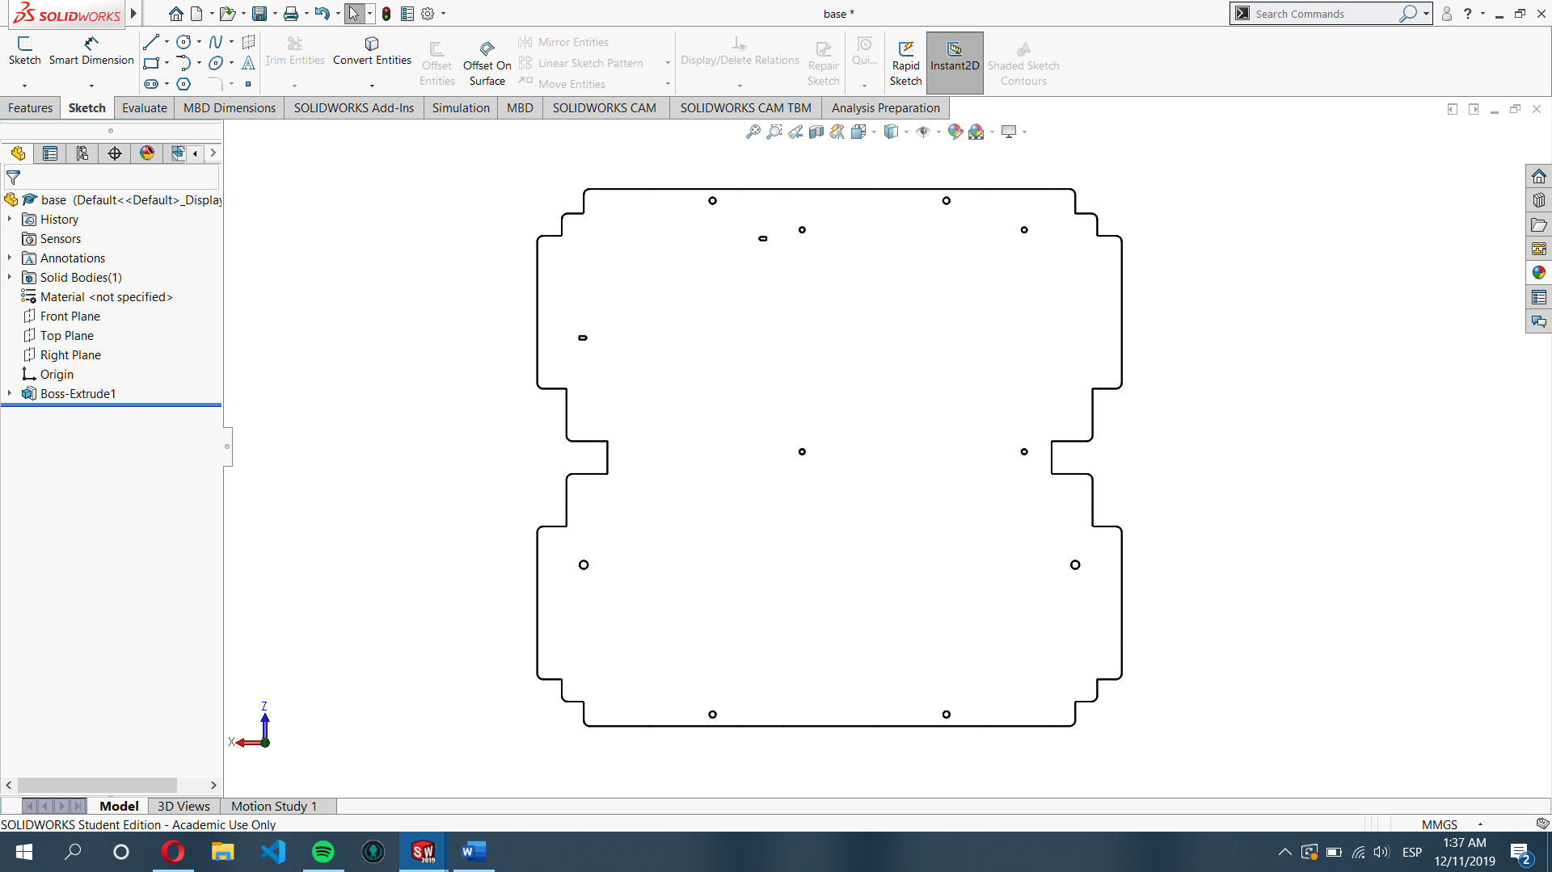

STEP 2: Use M5x8 bolts to secure the base for the components, a T-Nut for each hole must be inside the rails of the aluminum profile.

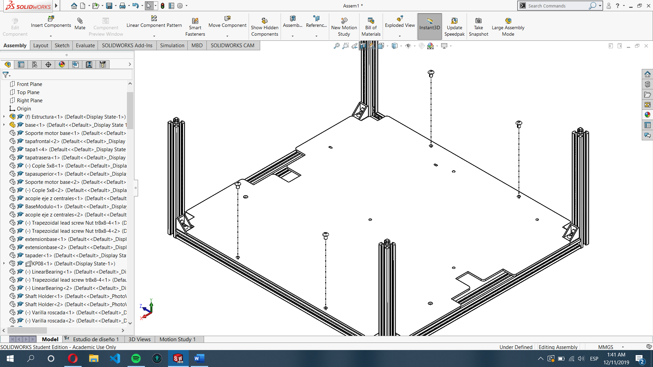

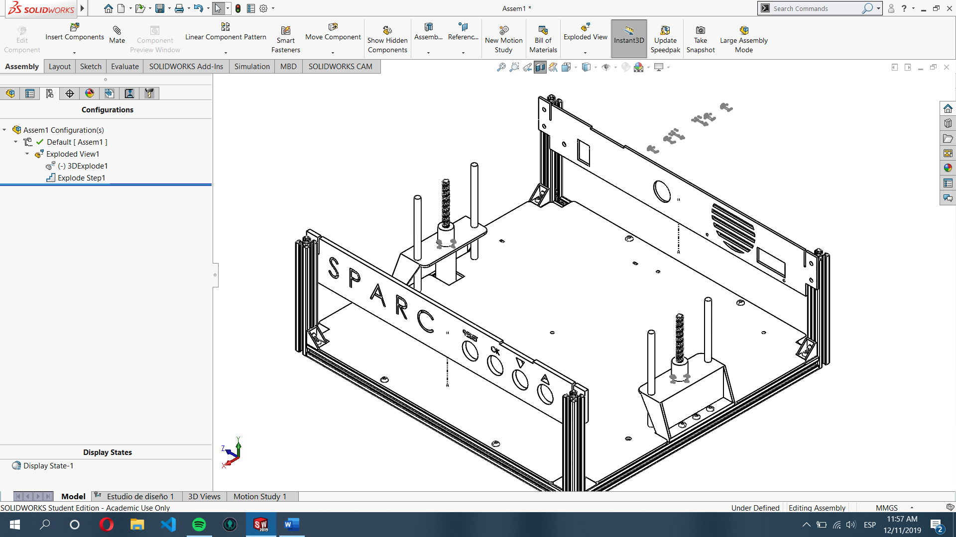

STEP 3: Use M5x8 bolts to secure the DC motor and linear guides holder, it must be fixed to the aluminum profile.

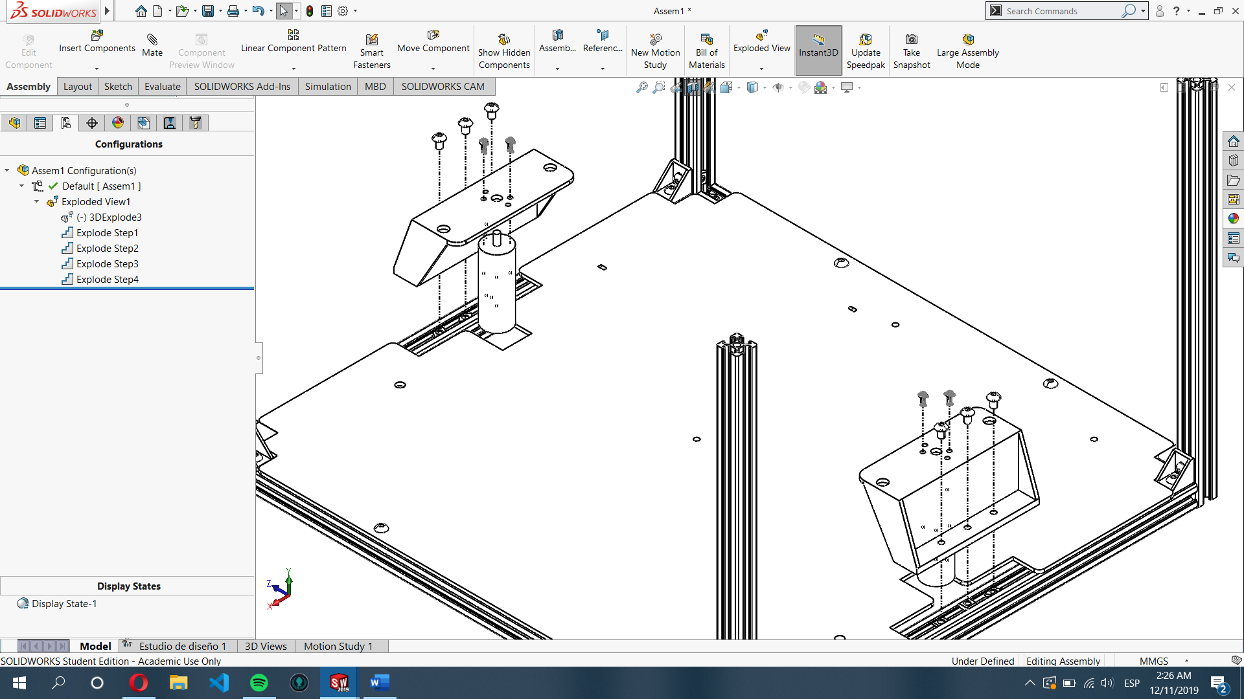

STEP 4

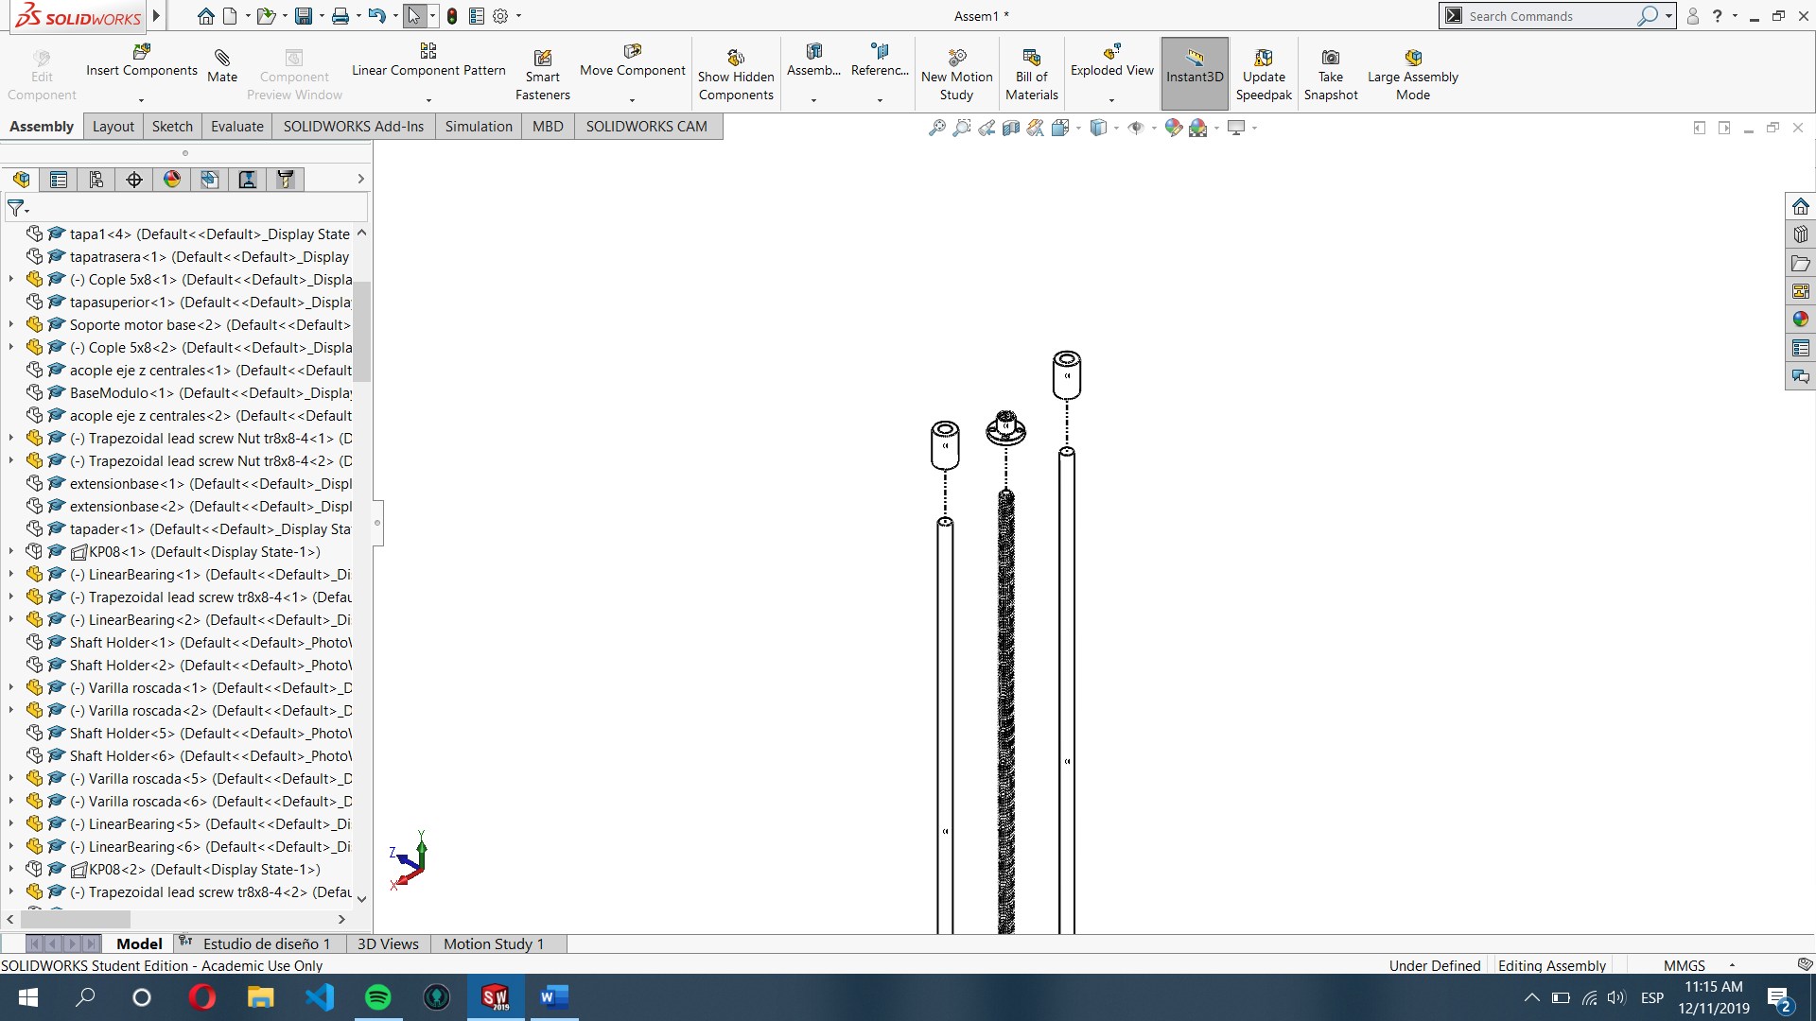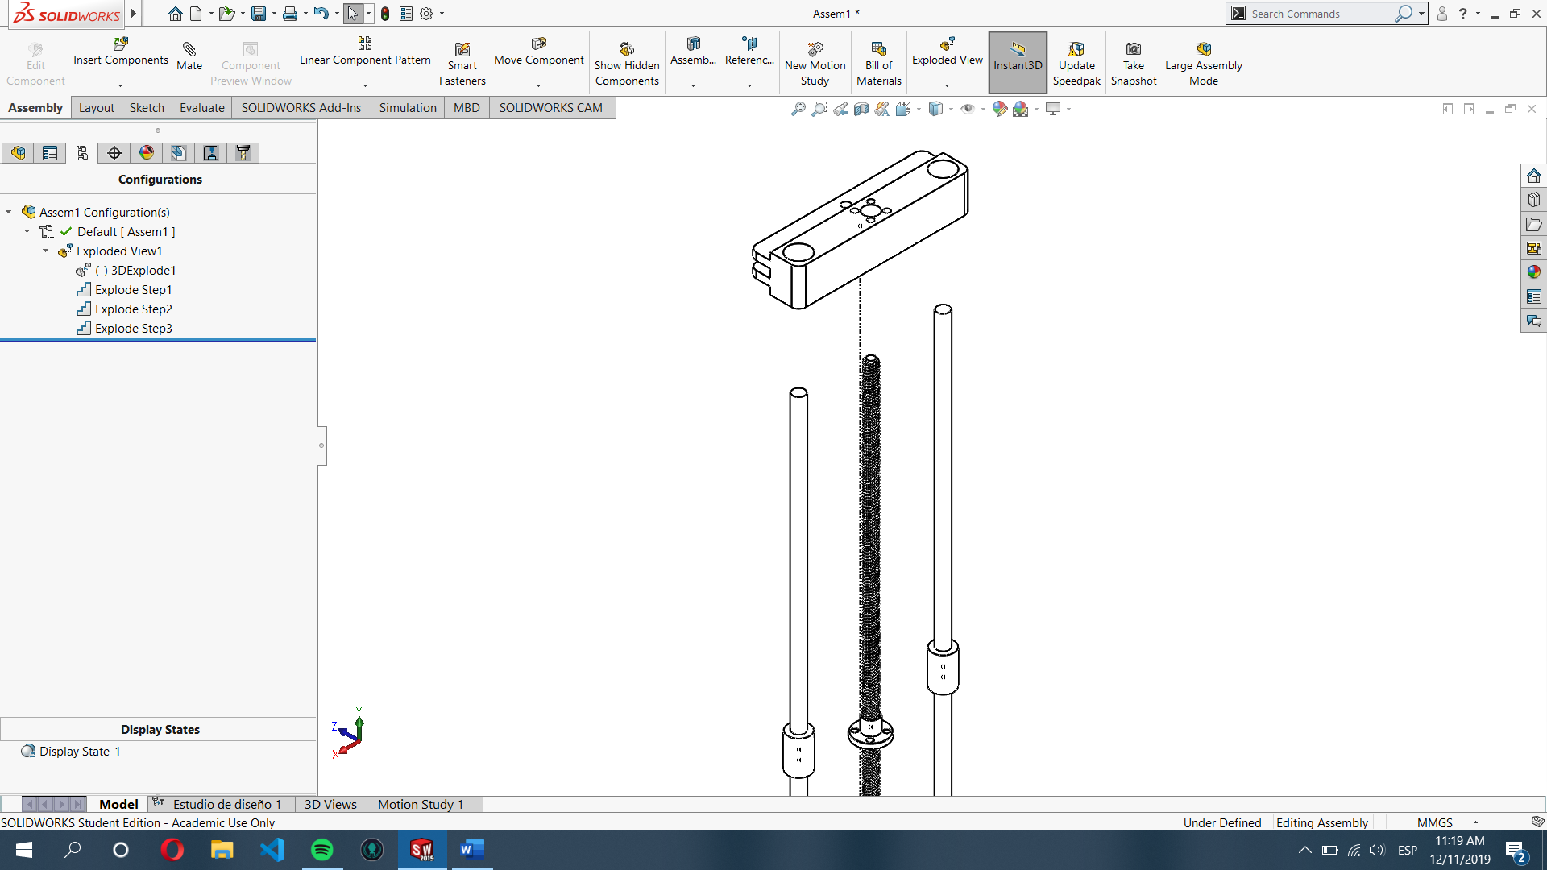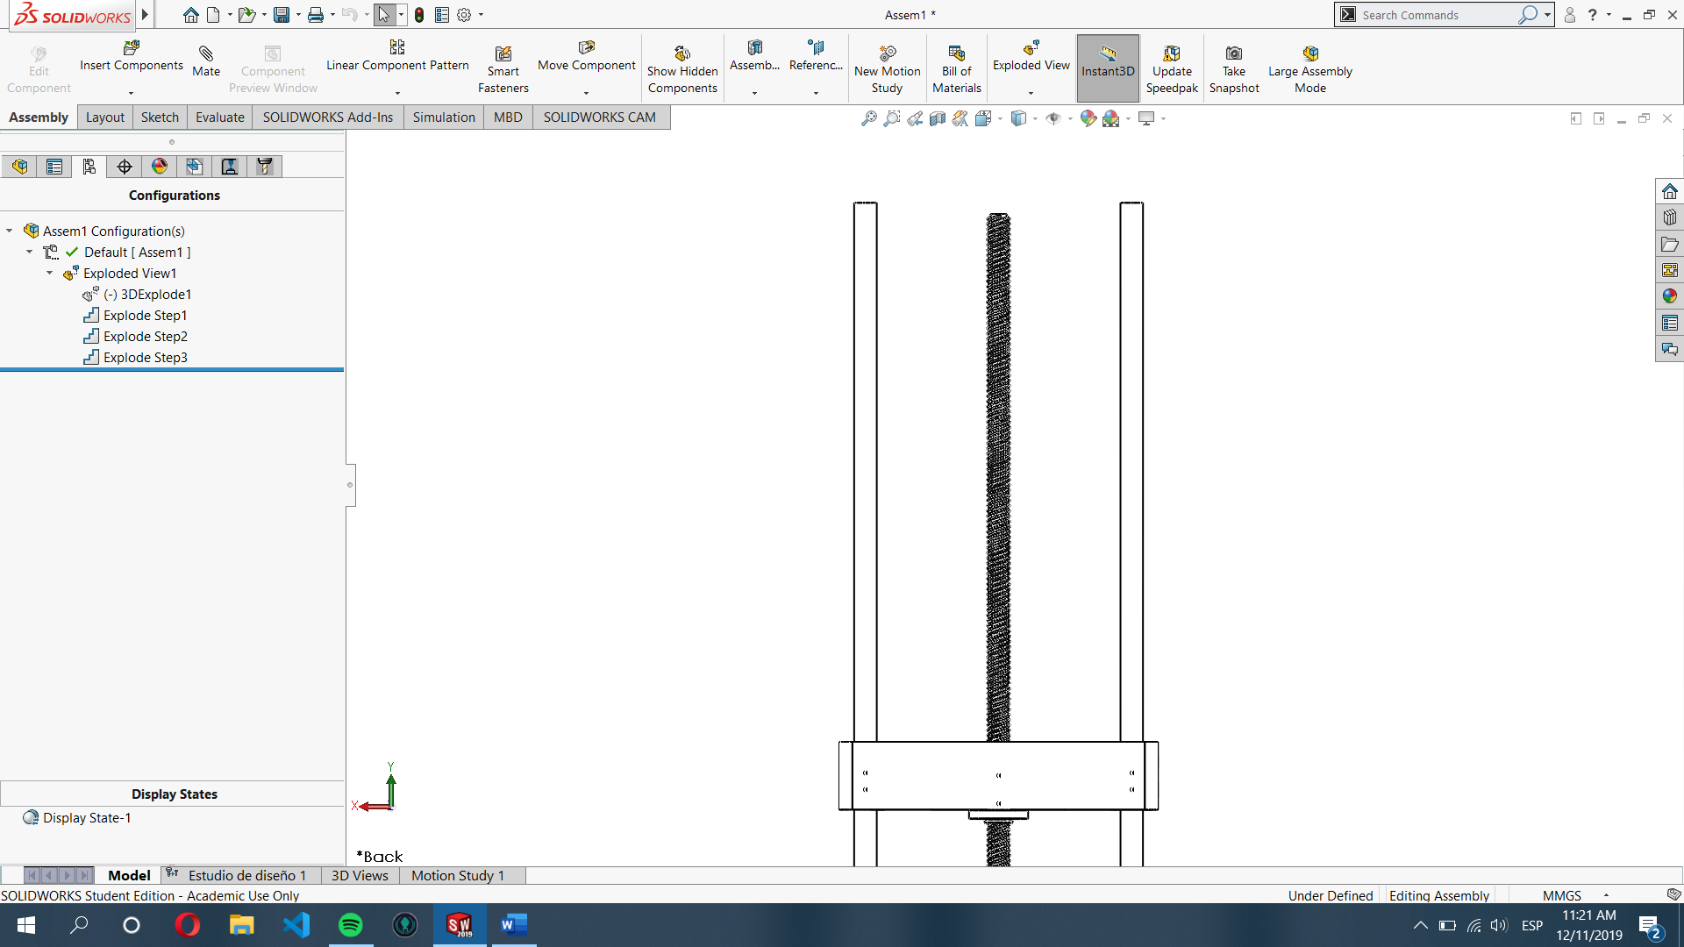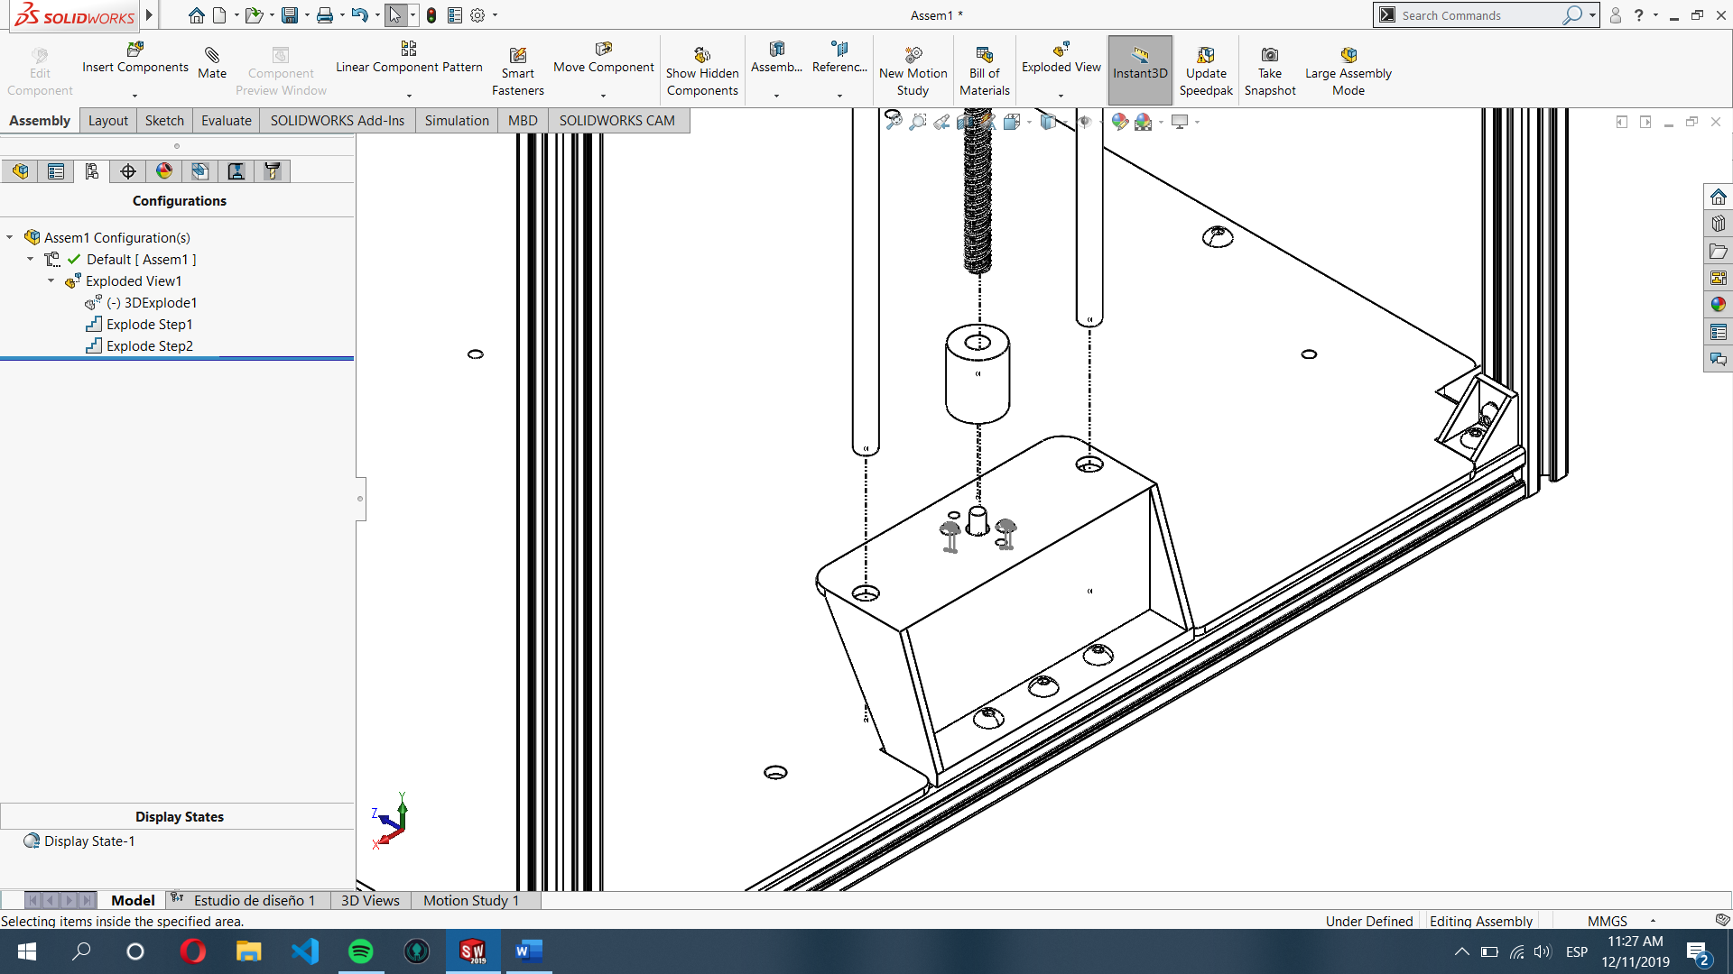

STEP 6: Adjust the coupler needed to secure the bearing to the profile.

STEP 5

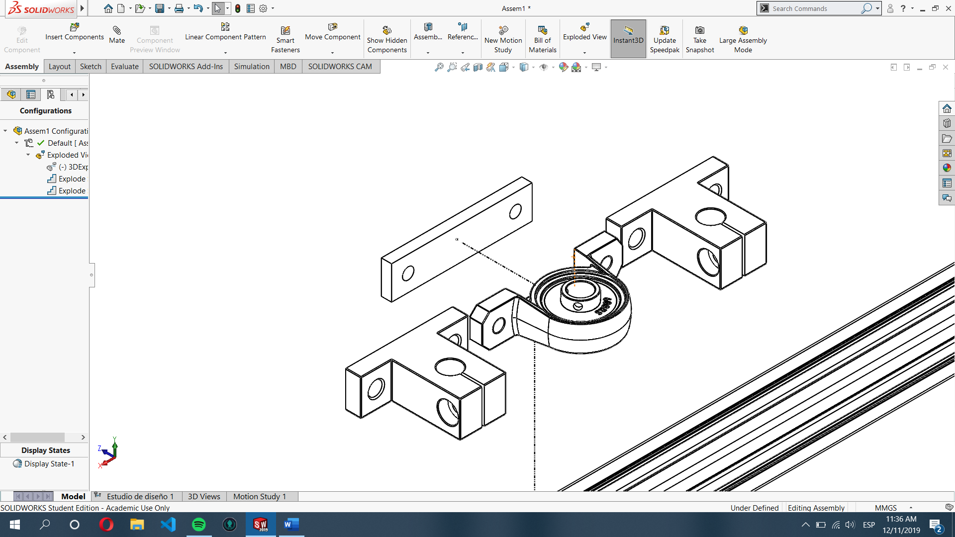

STEP 7: Fix the guide axis and bearing using 2 T-Nuts for each one, guide axis use M5x14 bolts, bearing holder uses M5x10 bolts.

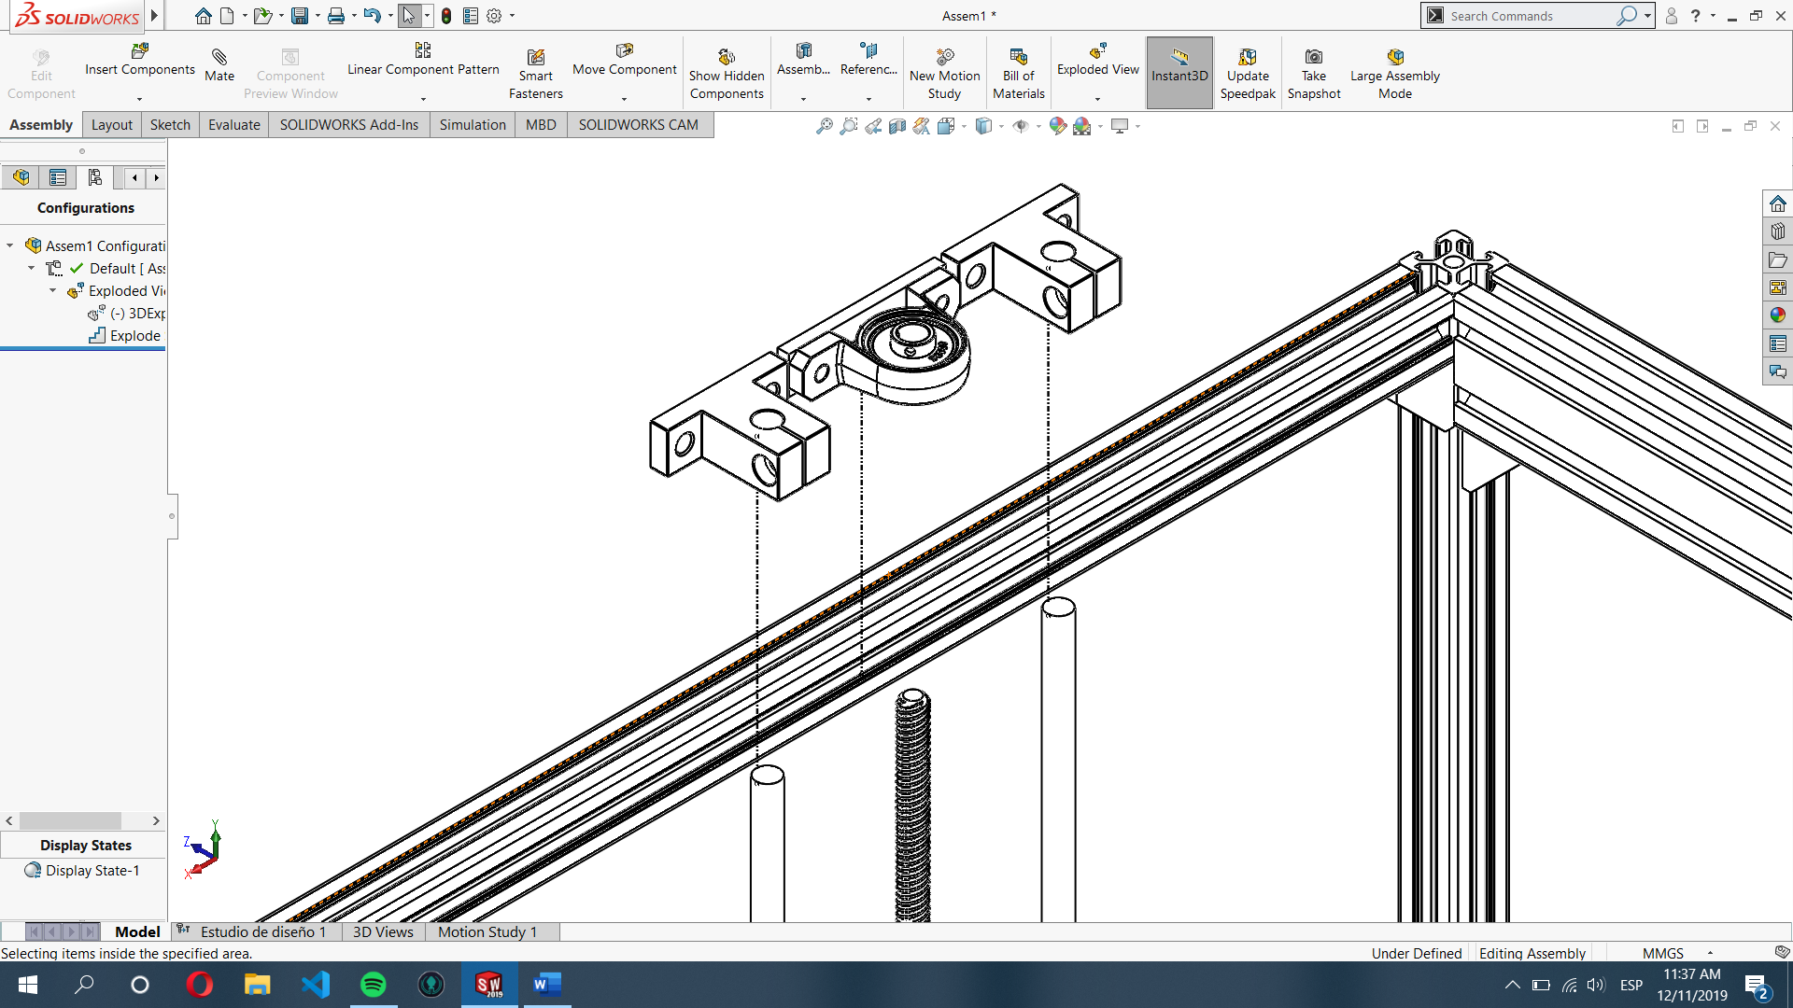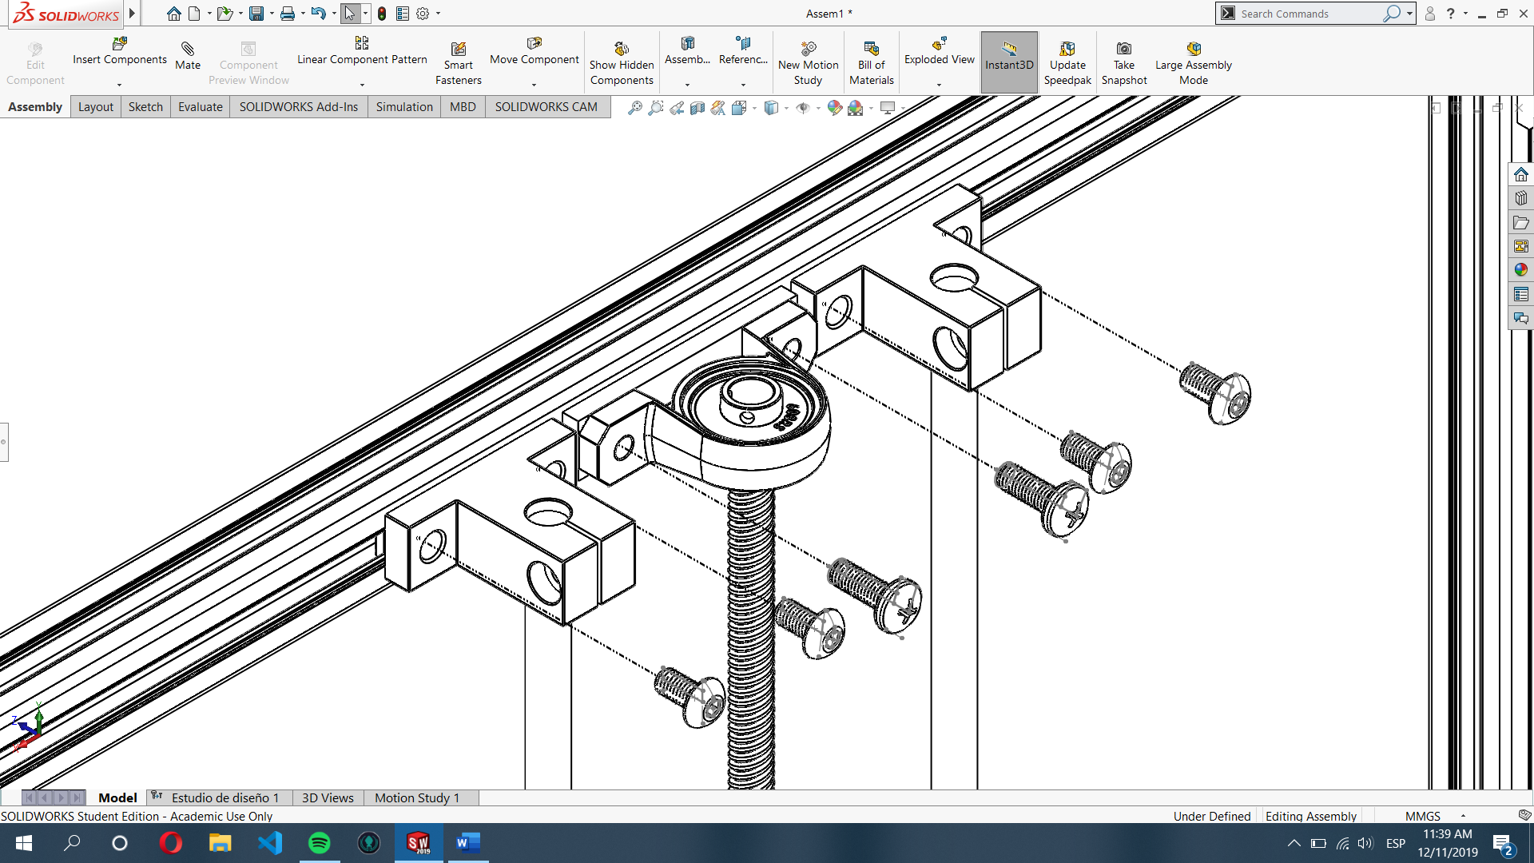M5x10 y M5x14

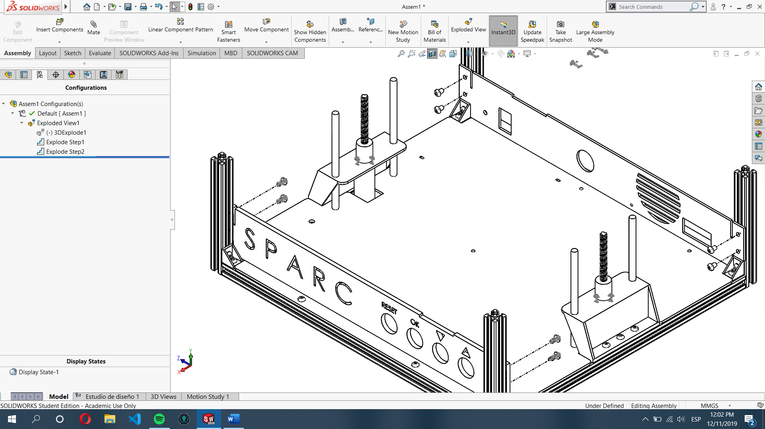

STEP 8: Use M5x8 bolts and T-Nuts to fix SPARC and VENT walls to the aluminum profile, it uses two T-Nuts and 2 bolts in each corner.

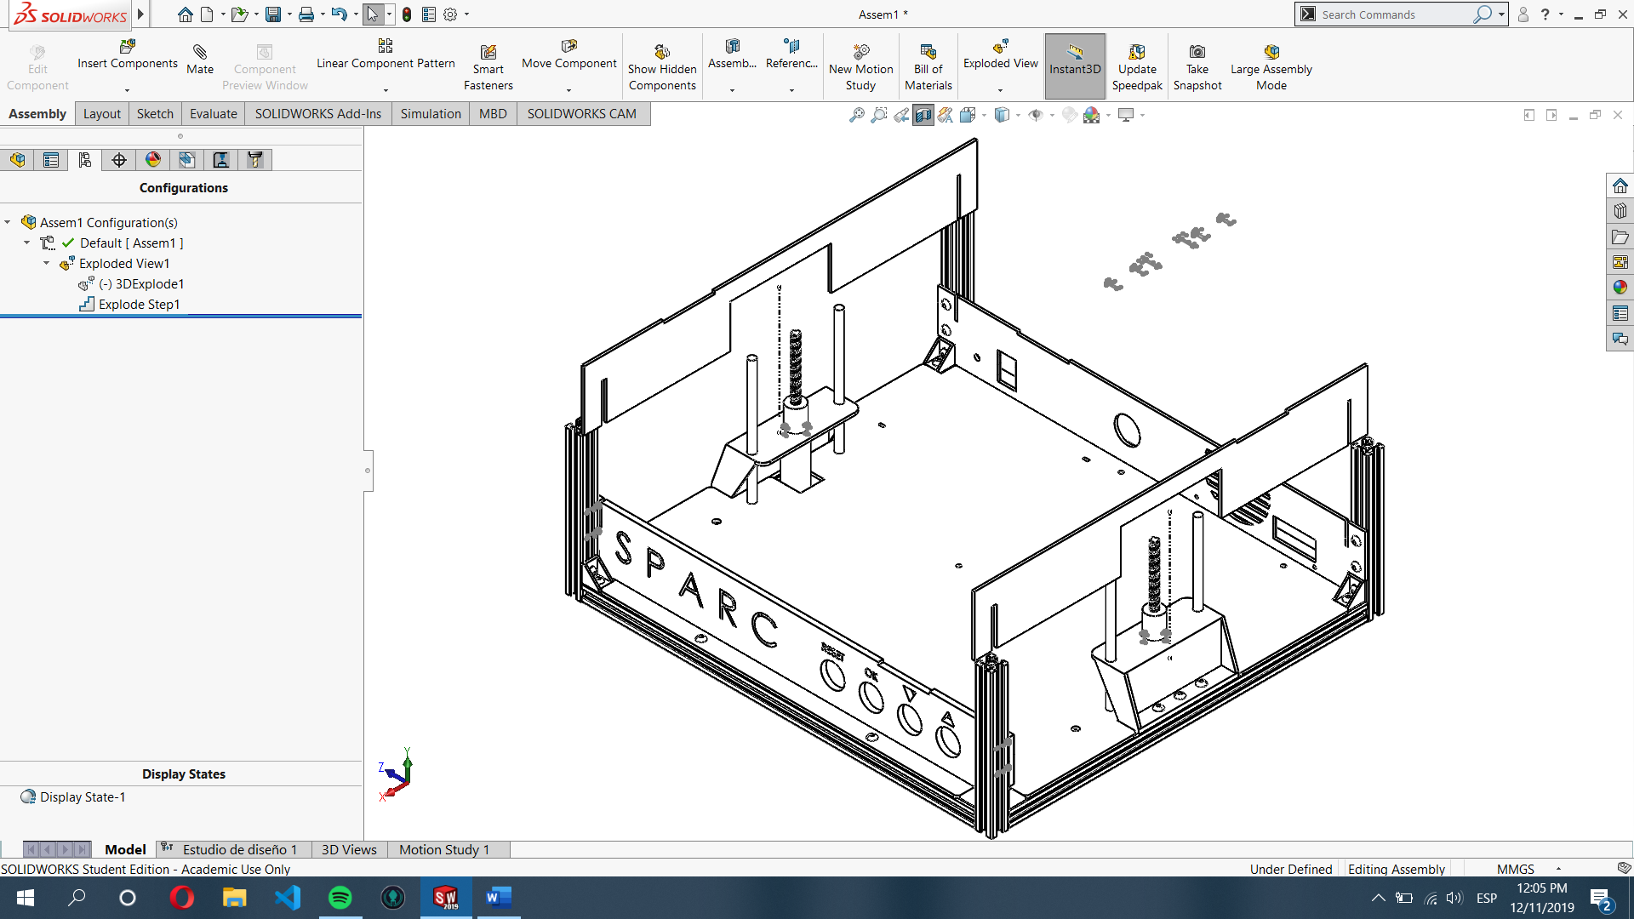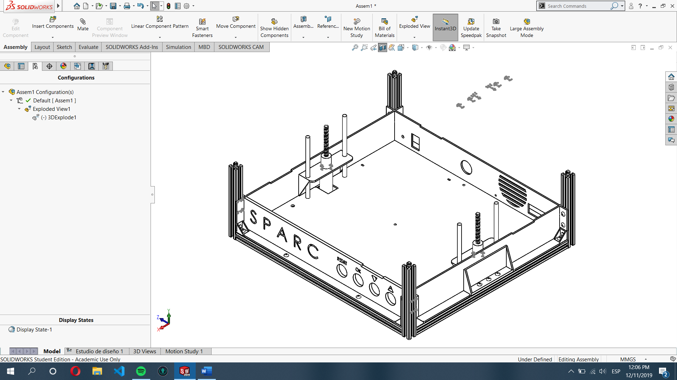

STEP 9: Place side walls in the grooves cut in the fixed walls.

STEP 10: Insert the fixture base grips on the groves shown on next page, the use M5x14 bolts and M5 nuts to fix it to the moving rail.

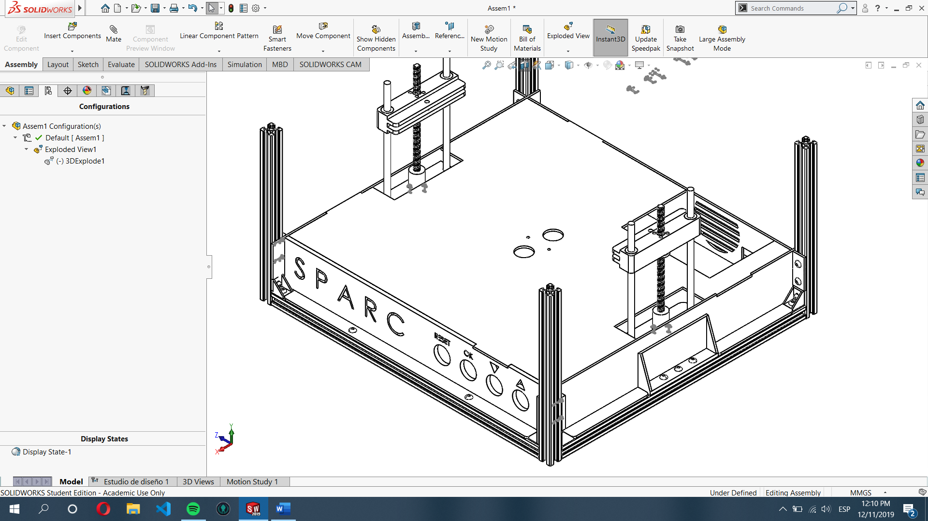

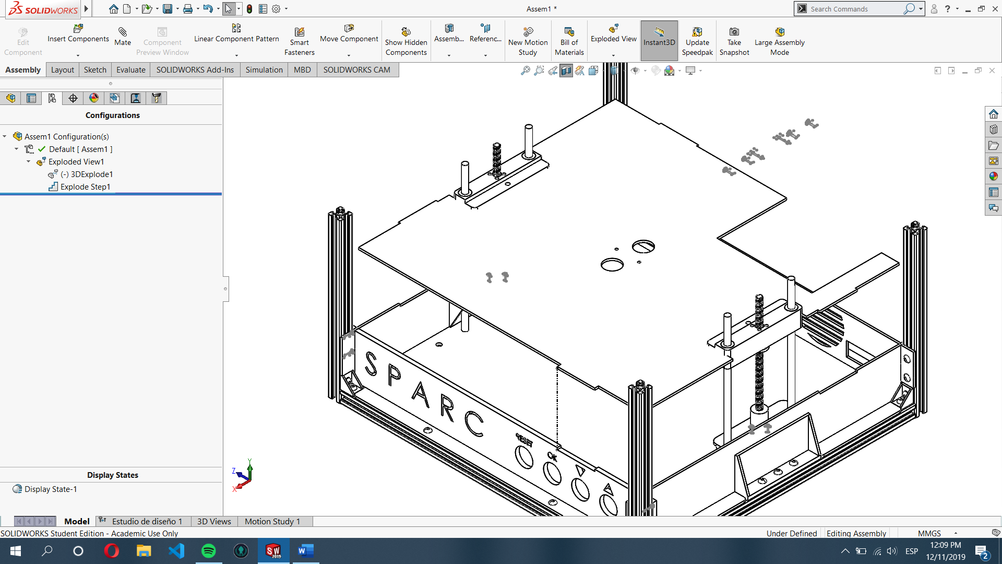

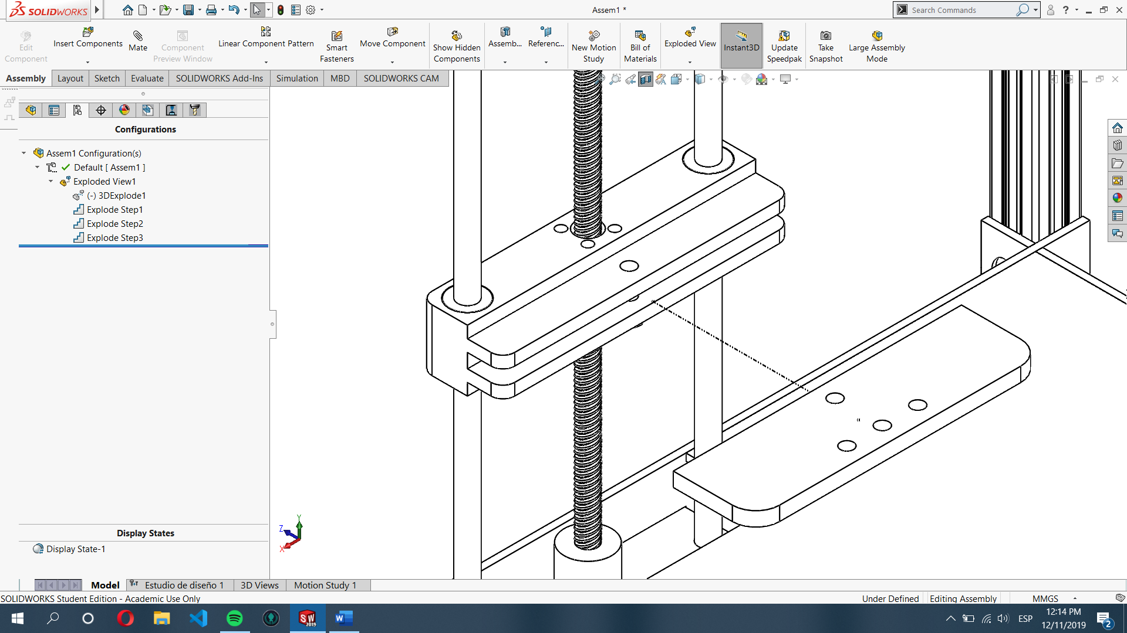

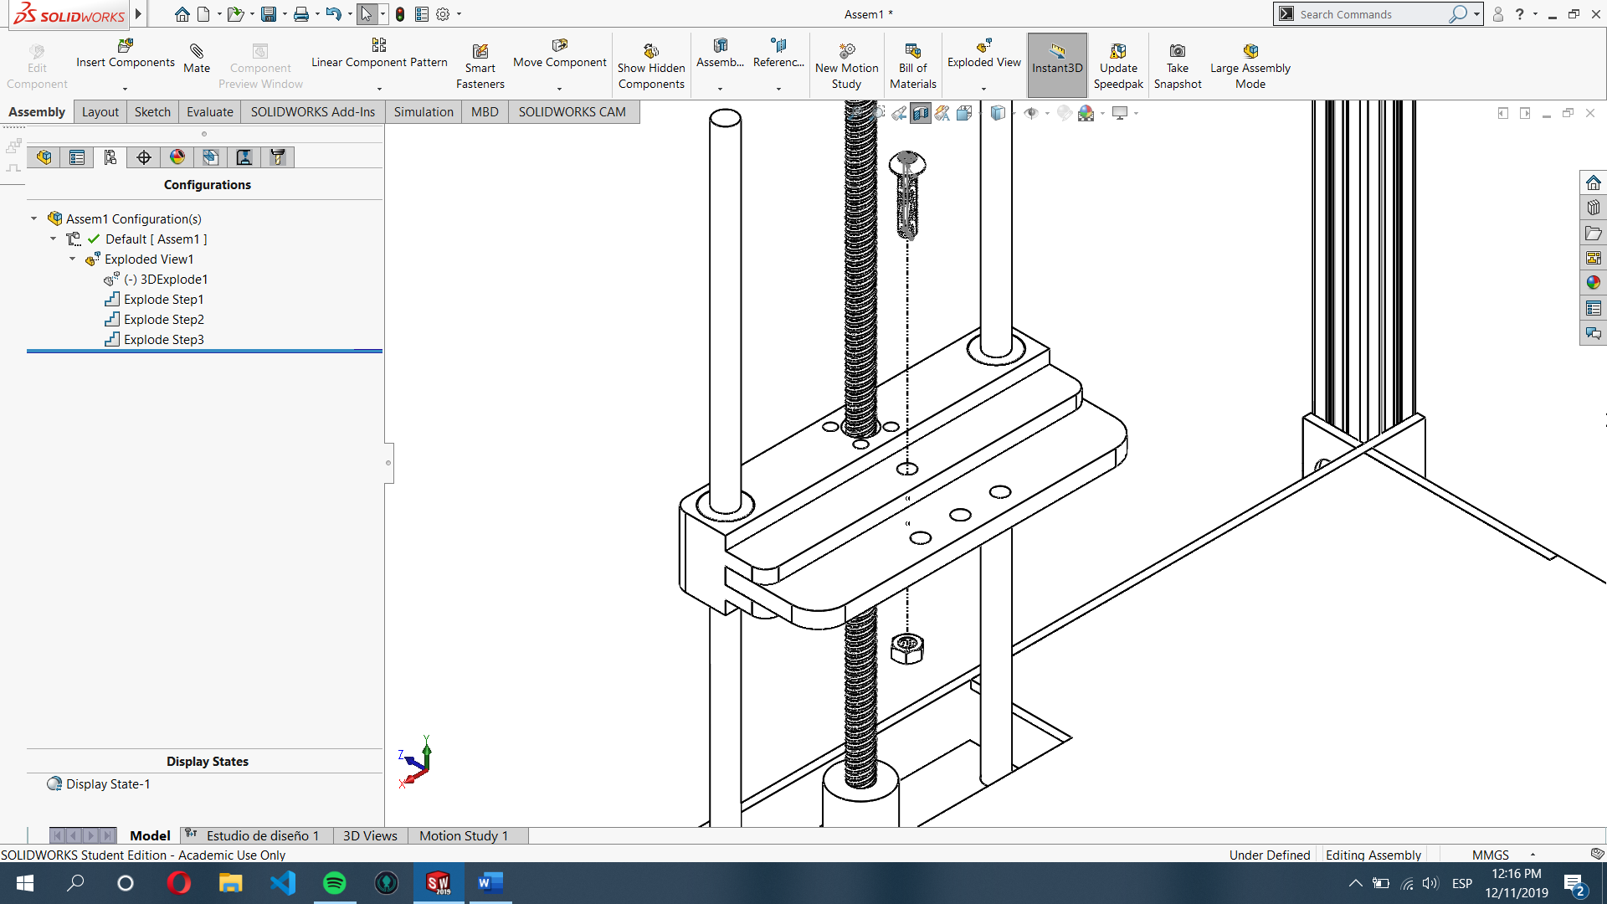

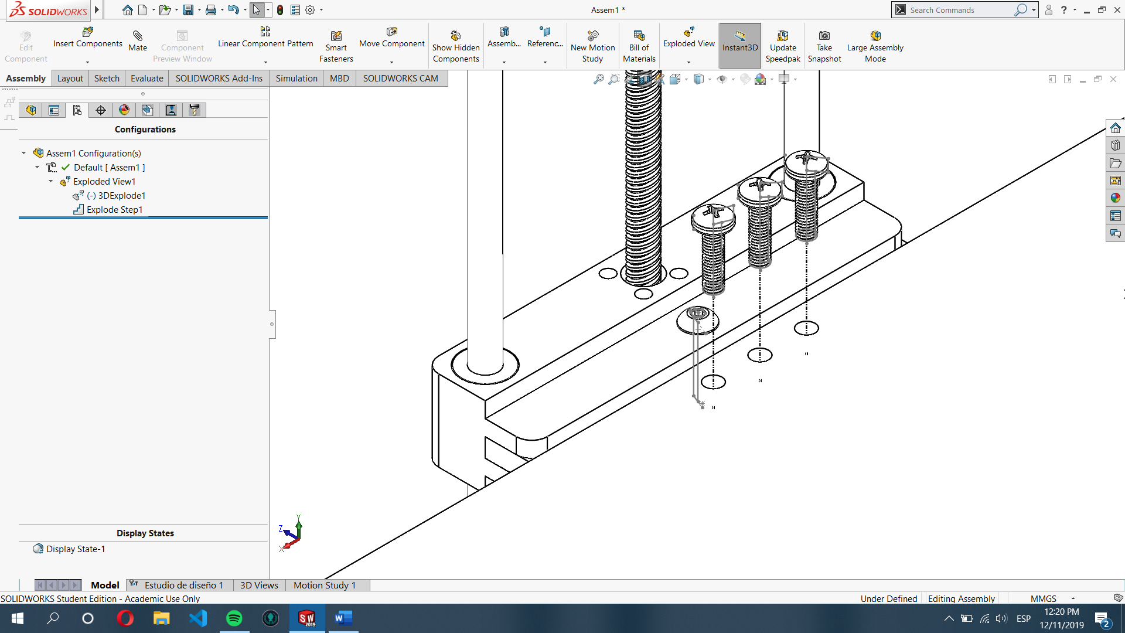

STEP 11: Assemble the fixture base grips with the proper fixture base using 3 M5x14 bolts and M5 nuts for each side.

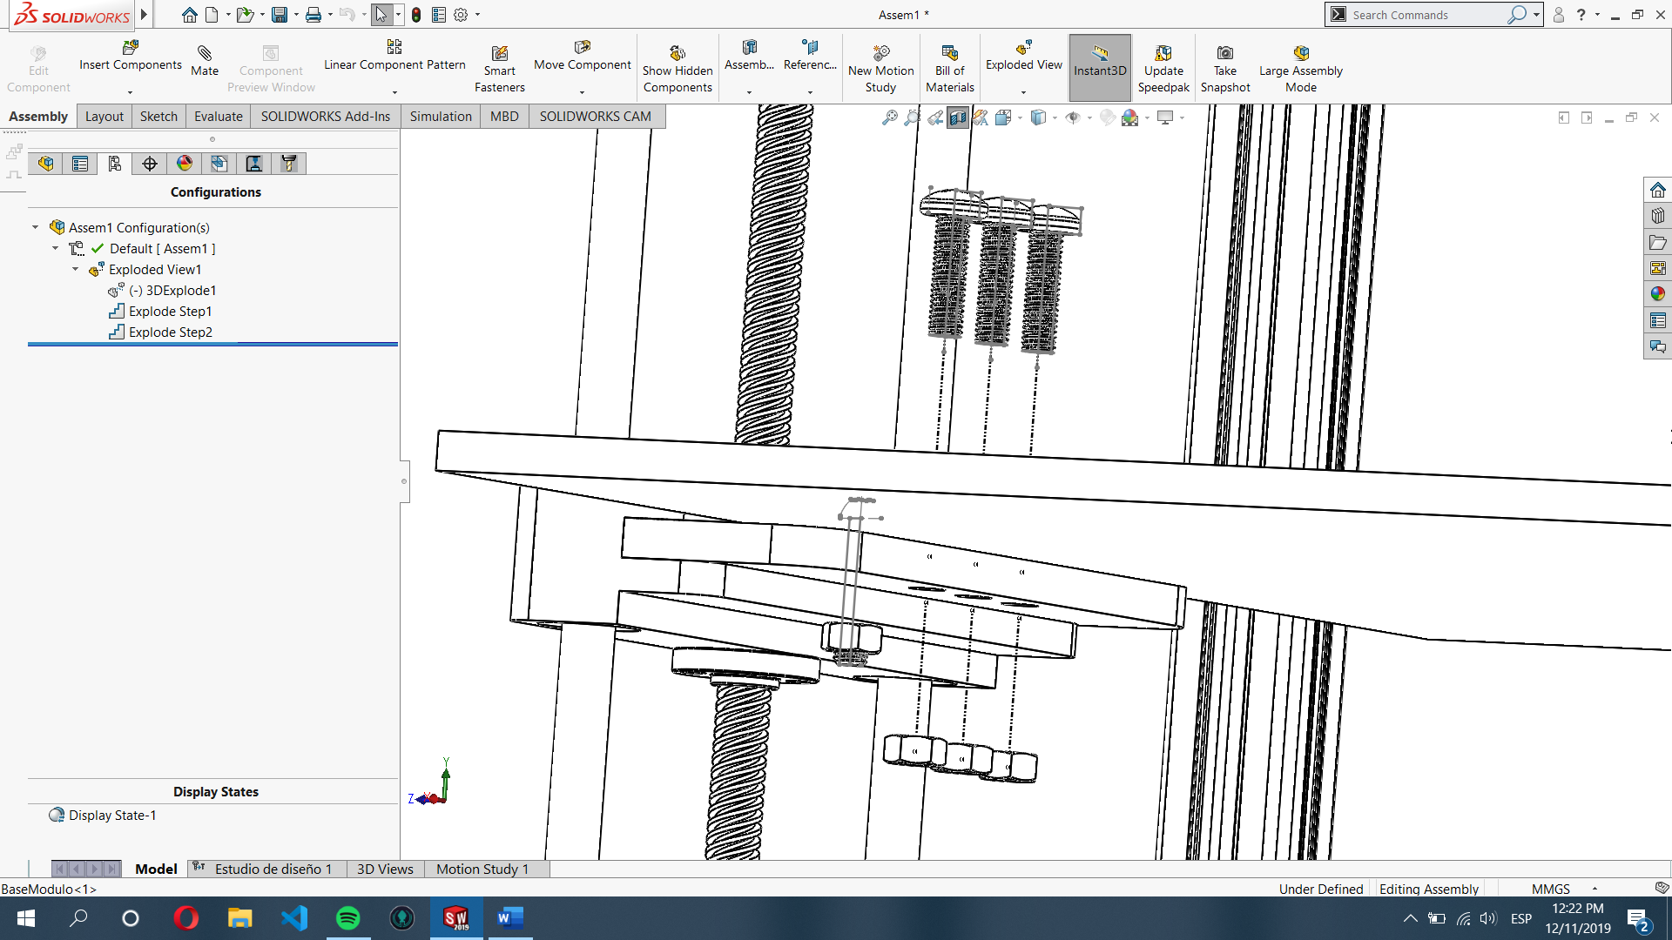

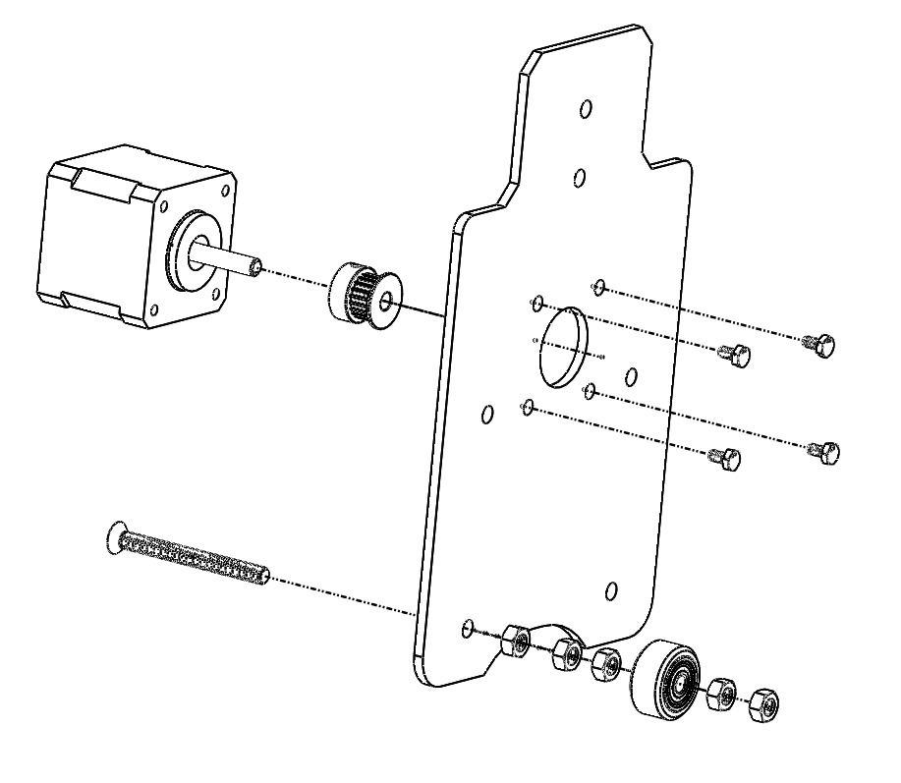

CART ASSEMBLY

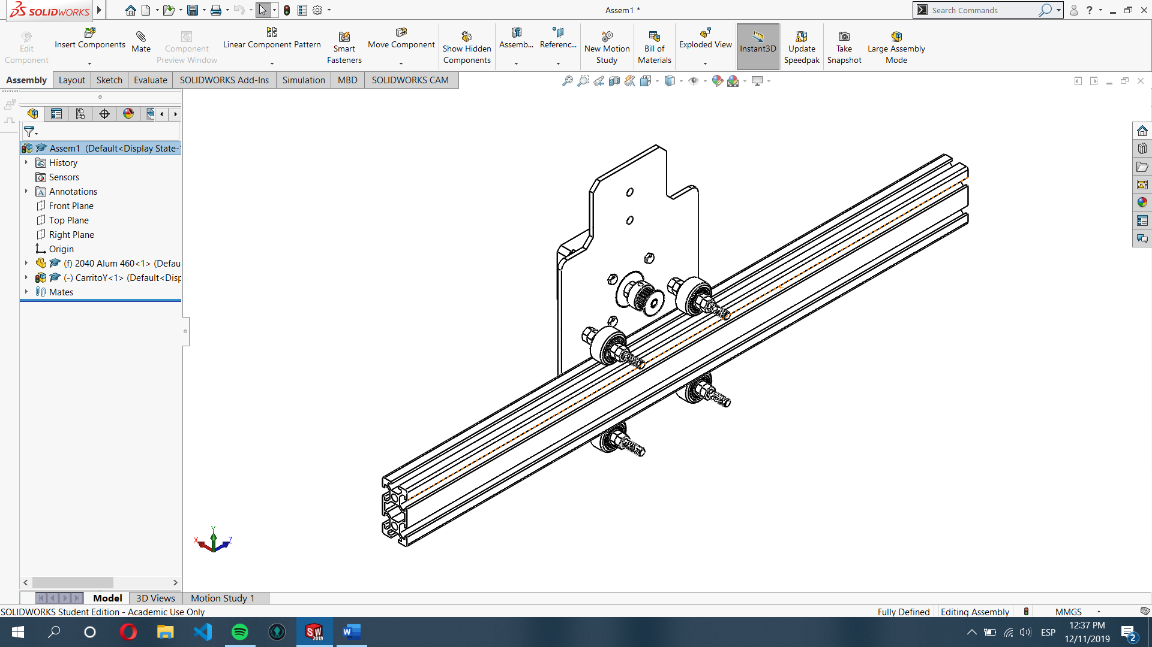

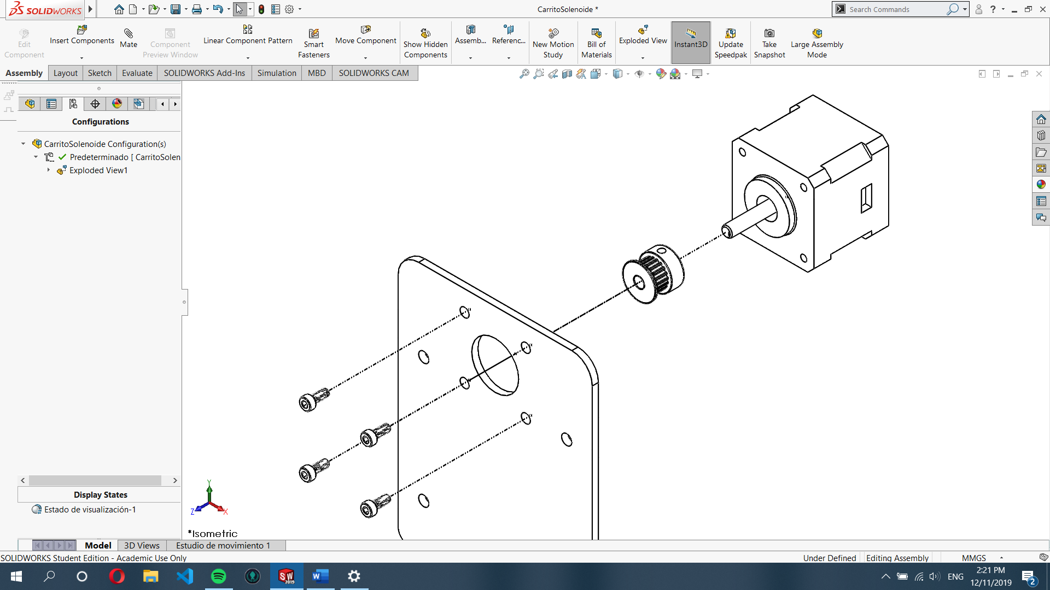

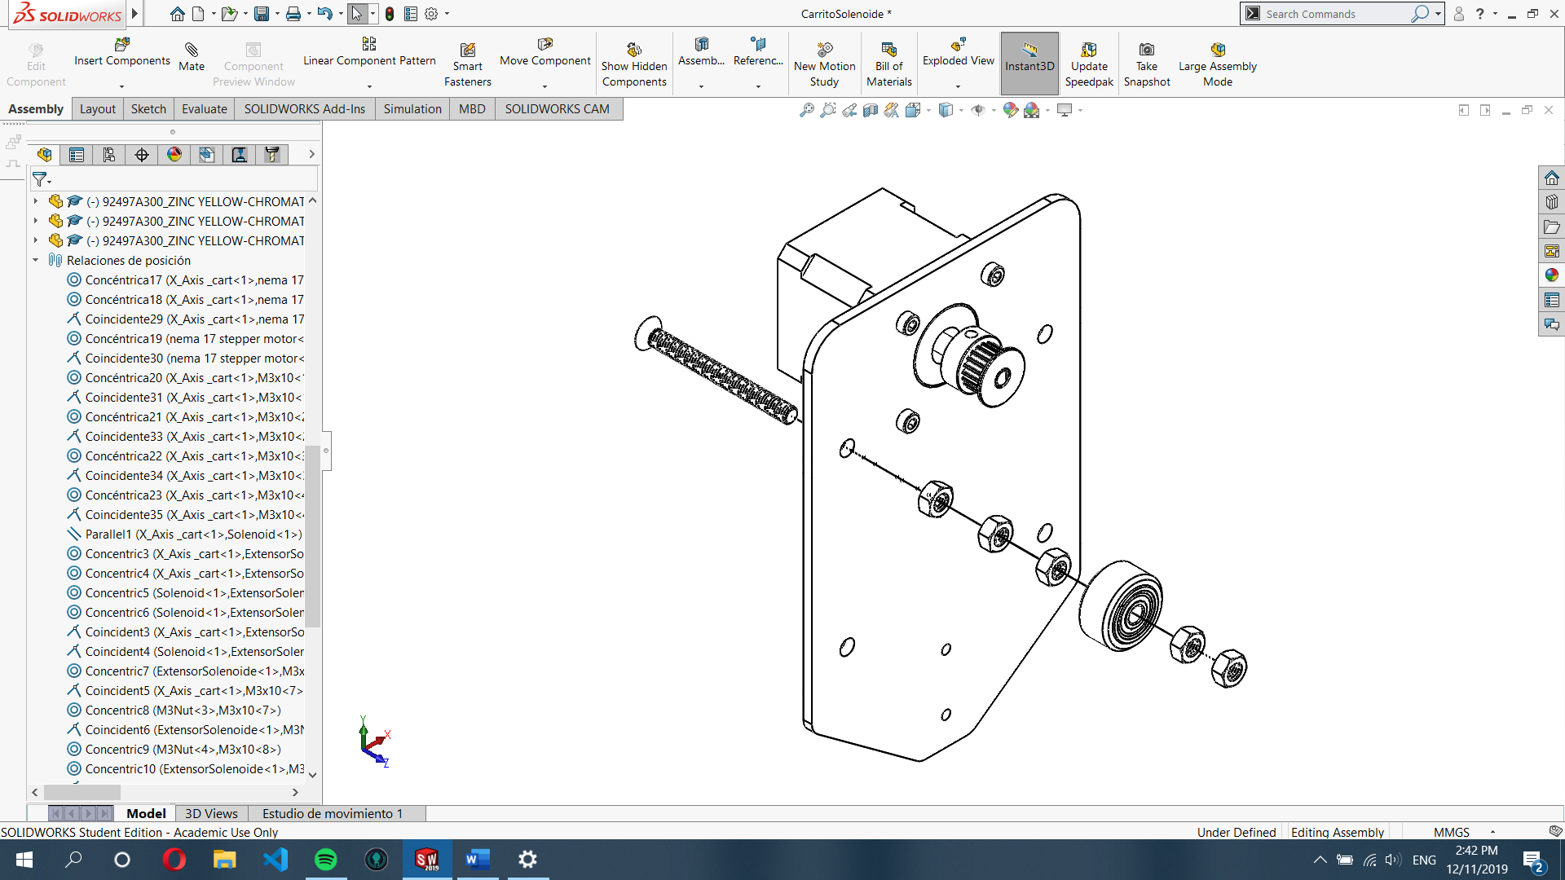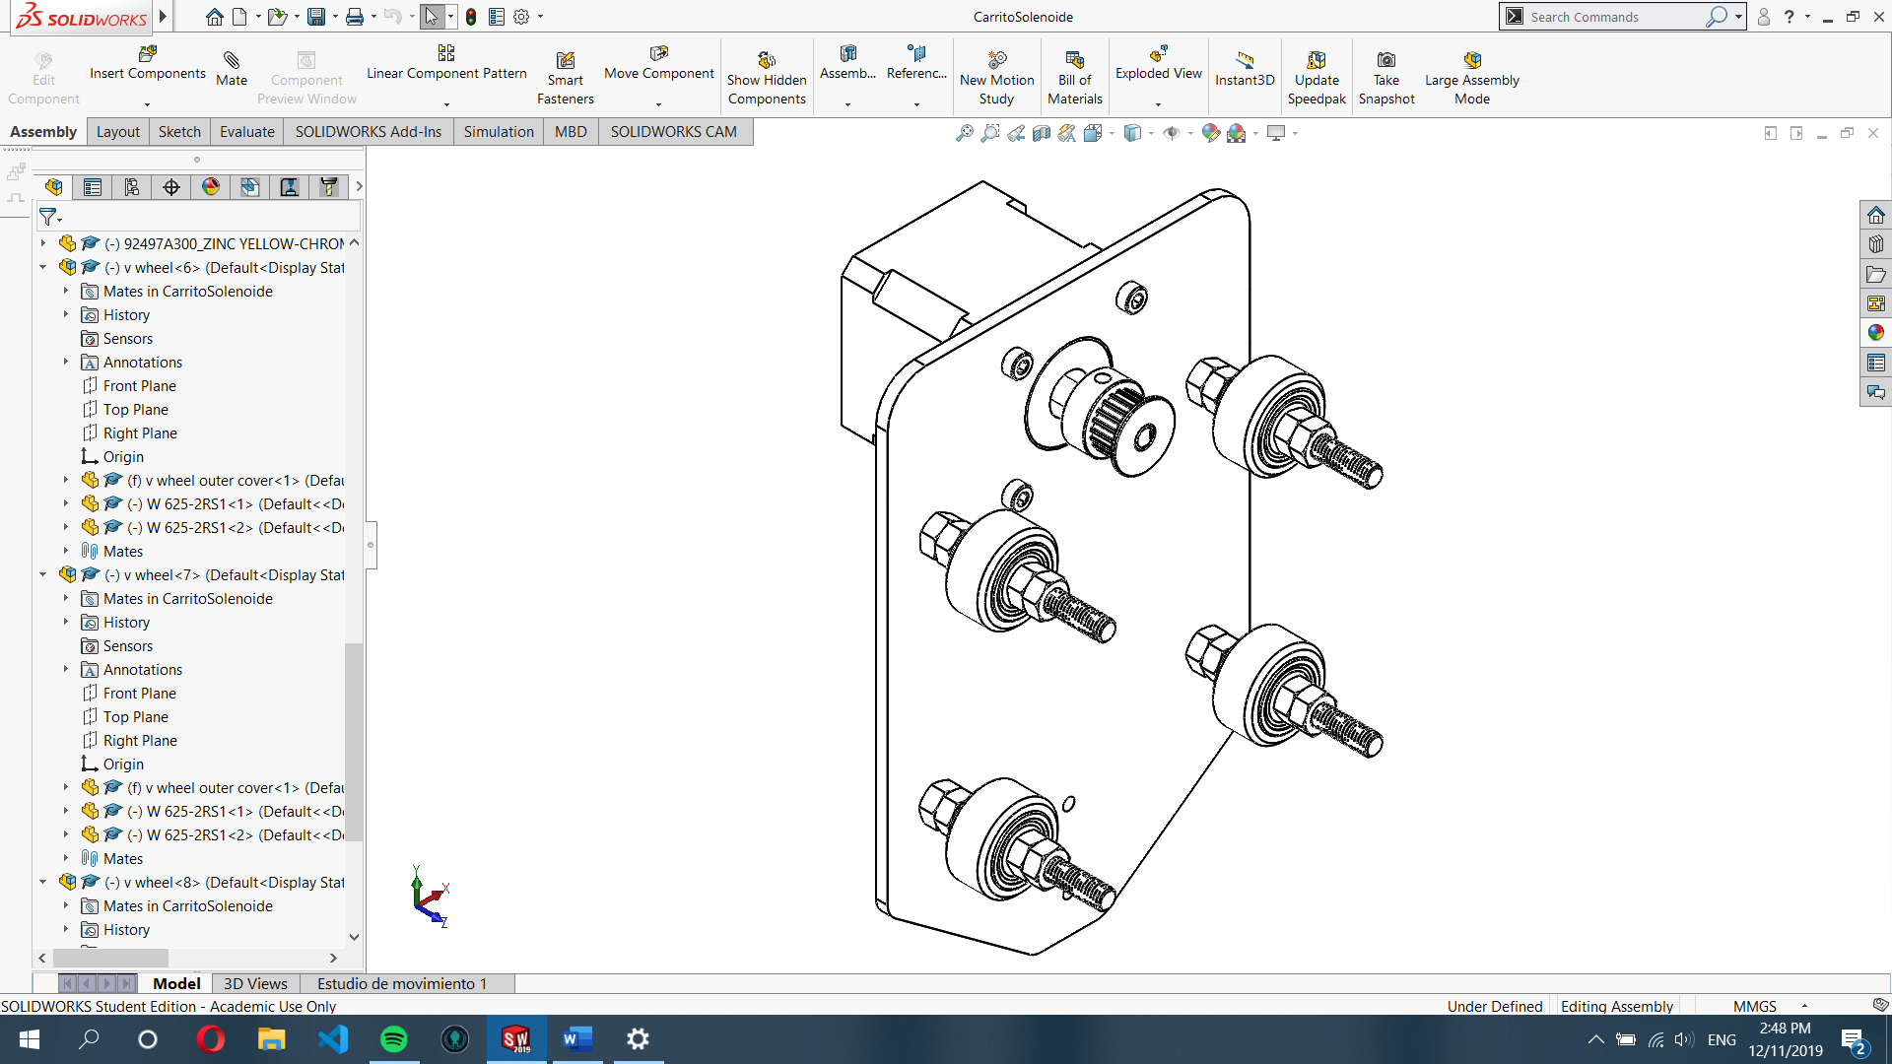

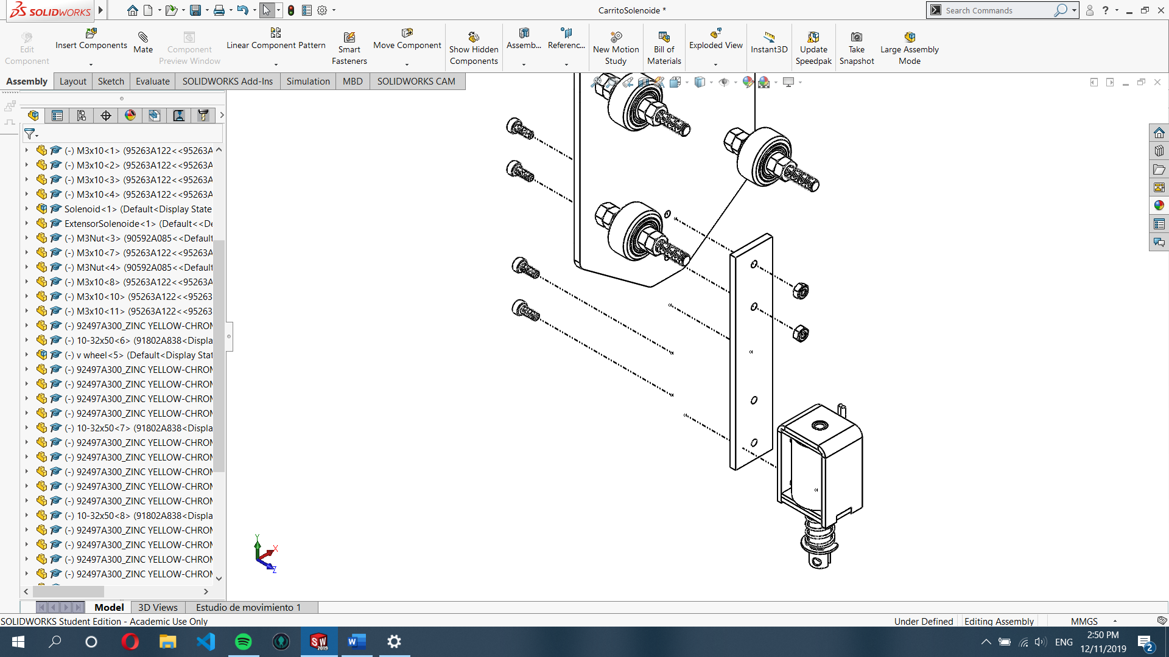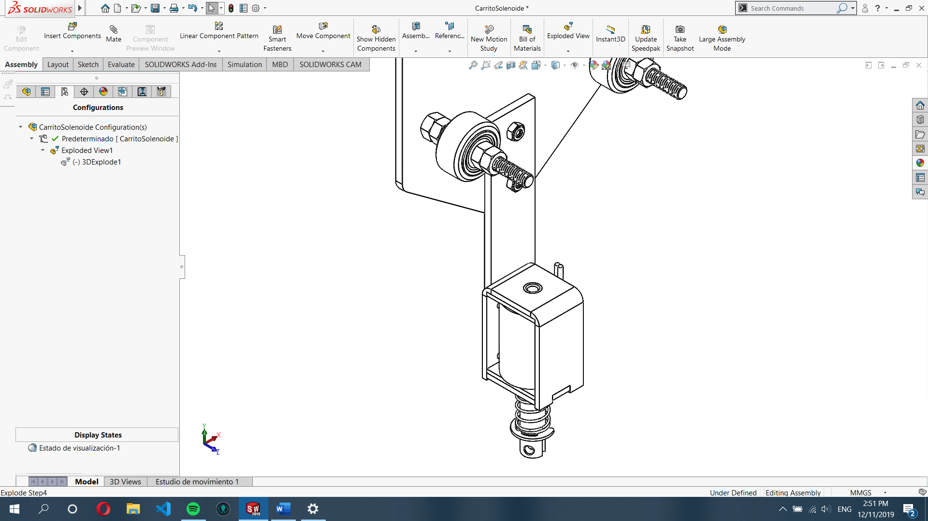

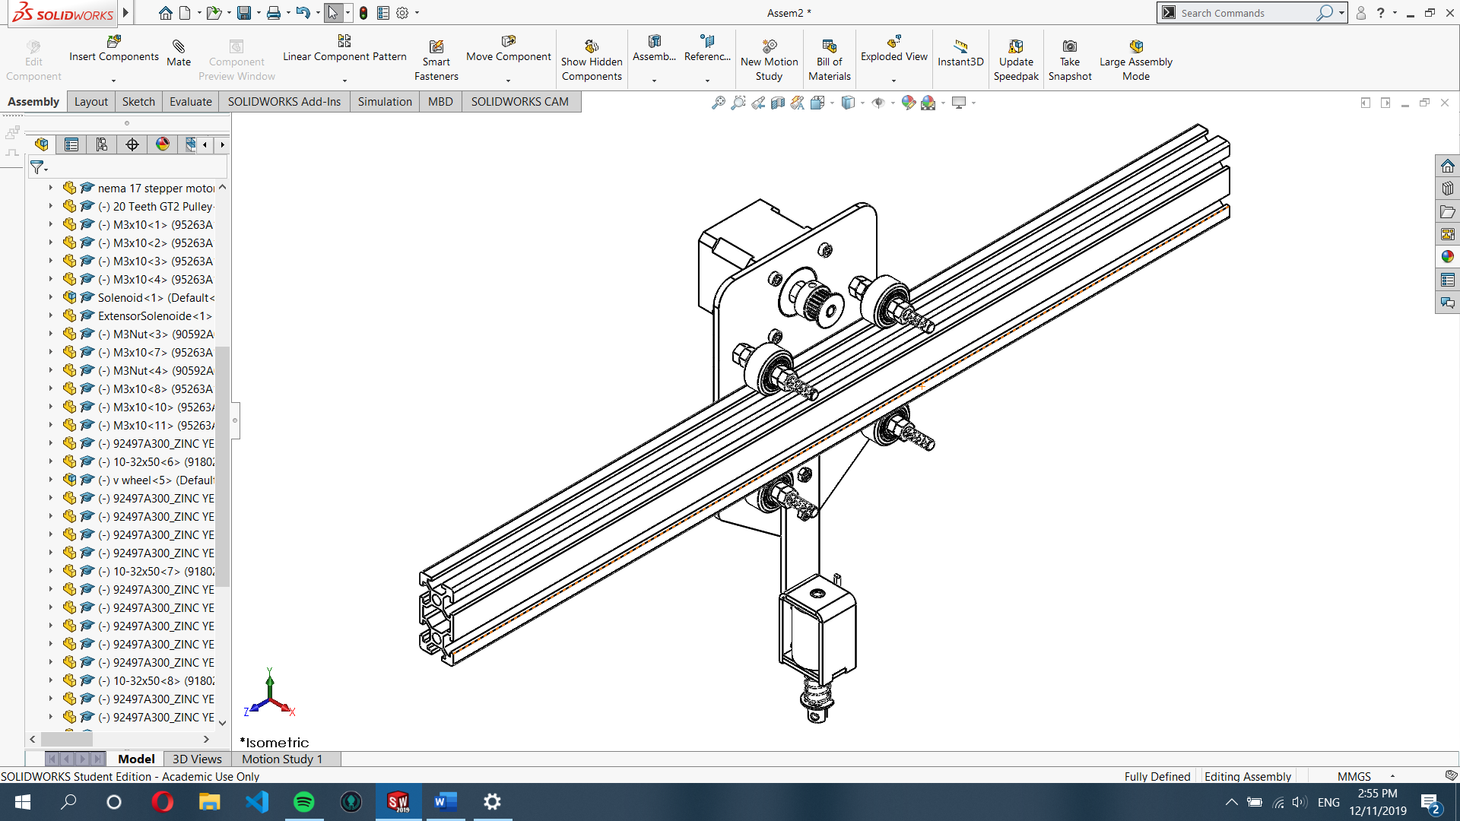

Cart and Profile “E”

STEP 12: Mounting Upper Axis on the main frame, see next page for details.

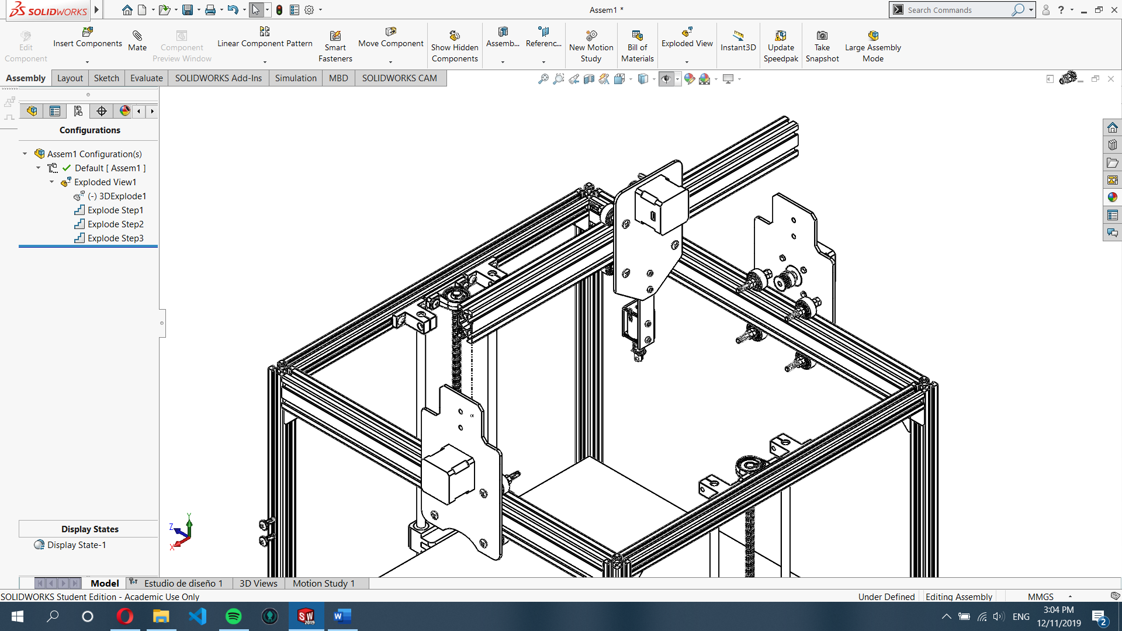

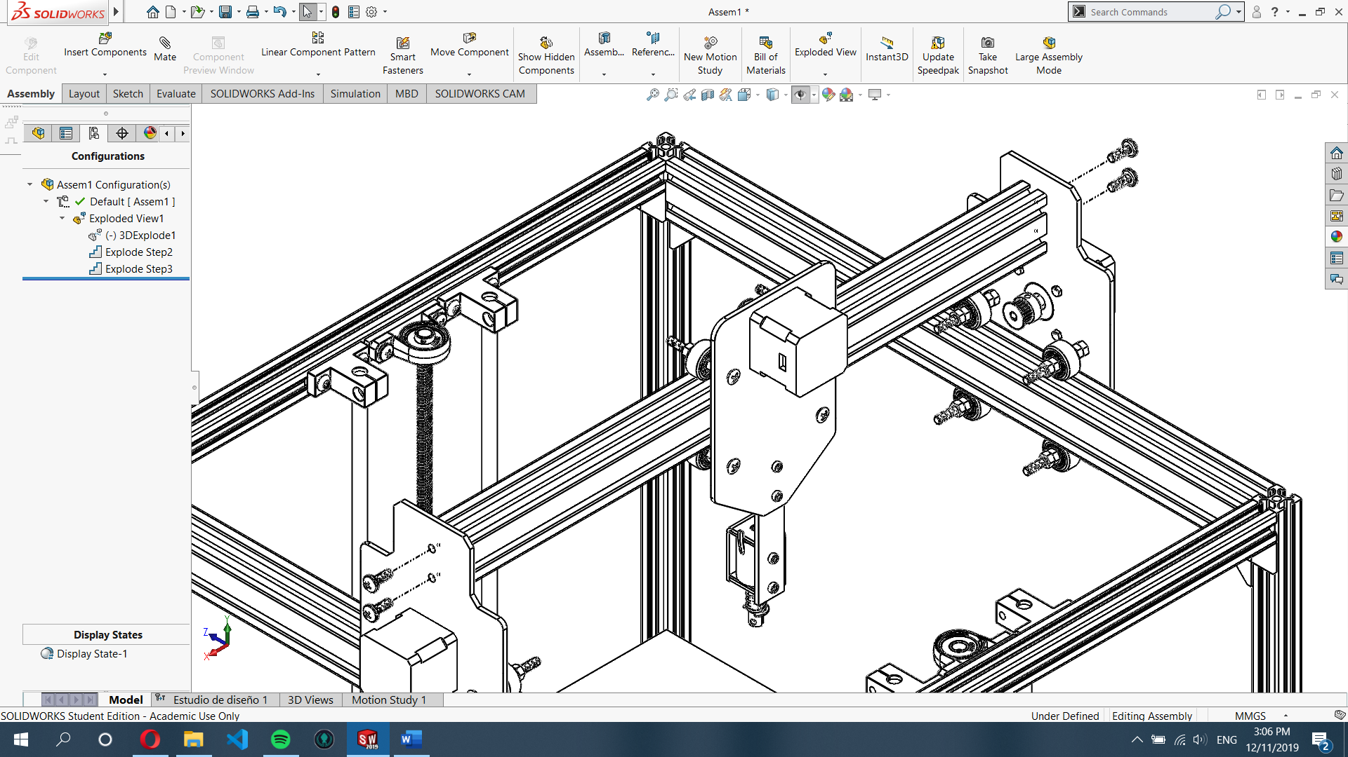

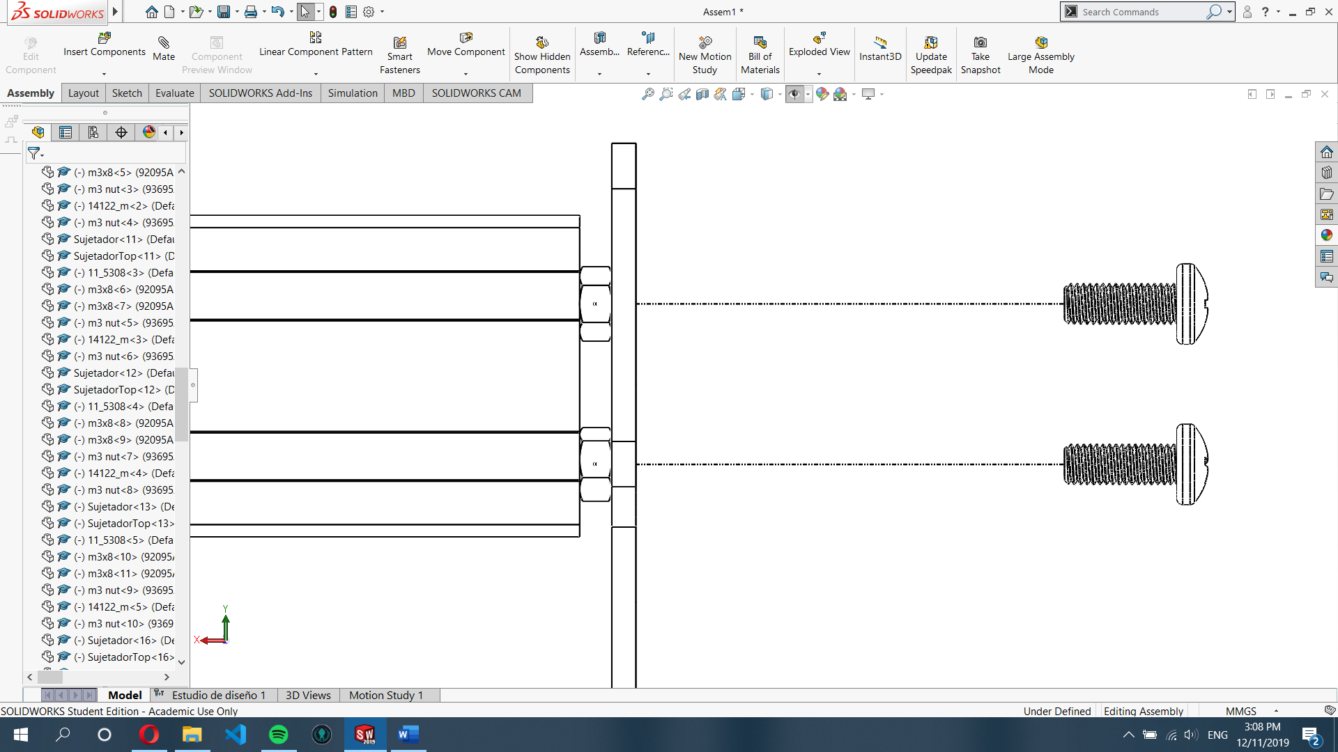

STEP 12: Screw 2 M5x10 bolts in M5 nuts then screw directly to the profile “E” threads.

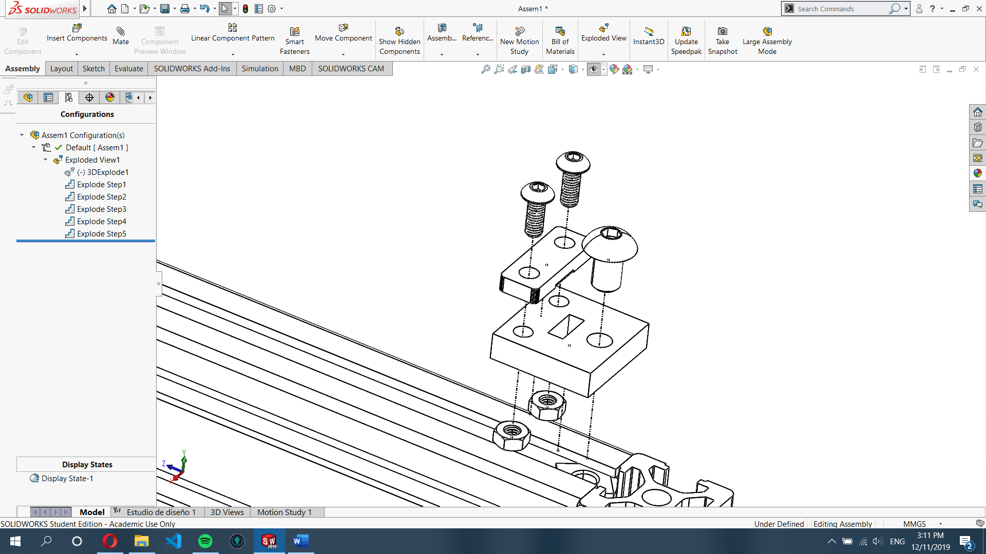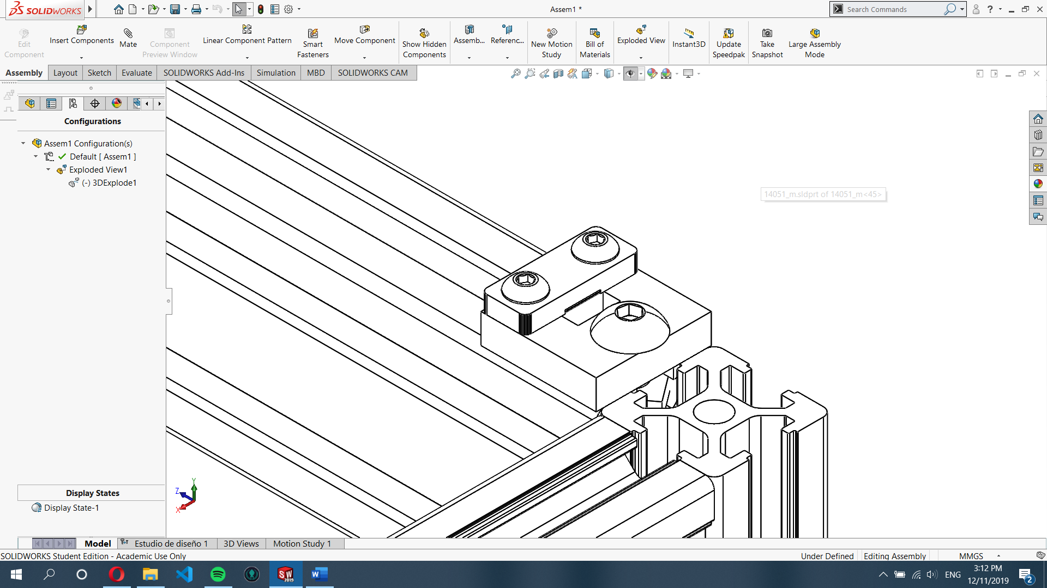

STEP 13: Mounting GT2 band holders, see picture for details.

